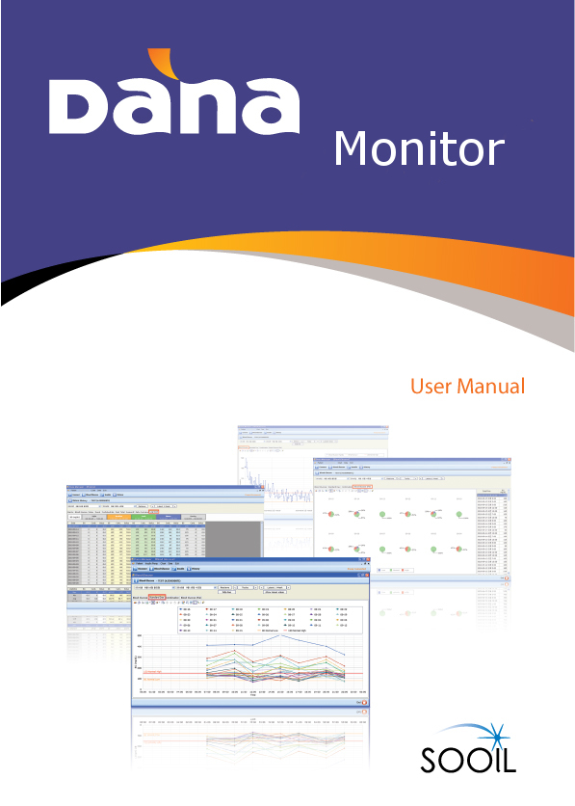
Contents

CHAPTER 1. BEFORE USING DANA MONITOR 1
I. Required Specifications 3

CHAPTER 2. HOW TO INSTALL DANA MONITOR PROGRAM 4
I. Installation of DANA Monitor 4
1. Installation Process 4
II. Bluetooth Connection 5
III. Connection Setting Between PC and DANA Insulin Pump 6
1. Connection Process 7

CHAPTER 3. FUNCTION 7
I. Registration 8
1. Registration Process 8
II. Connection 8
1. Connection Process 9
III. Blood Glucose 9
1. Blood Glucose 9
2. Standard Day 10
3. Combination 11
4. Blood Glucose(Pie) 11
IV. Insulin 12
1. Daily Total Dose 12
2. Insulin Trend 13
3. Bolus Dose 13
4. Day by Day 14

V. History 14
1. Alarms 14
2. Blood Glucose 15
3. Bolus 16
4. Basal 16
5. Carbohydrate 17
6. Daily Total 17
7. Suspend 18
8. Daily Overview 18
9. Log Book 19

CHAPTER 4. MENU BAR 19
I. Patient 20
1. New 20
2. List 20
II. Insulin Pump 21
1. Disconnect 21
2. History Download 22
3. Pump Status 22
4. Setting 23
5. Bolus 23
III. Chart 24
1. Blood Glucose 25
2. Insulin 25
IV. Insulin 25
1. History 26
2. Upload 26
V. Exit 26

Chapter1. Before using DANA Monitor

I. Required Specifications

- IBM-compatible PC running Windows XP, Windows Vista, and Windows 7 and above.
- One available USB
- 40MB free hard disk space
- Minimum 64MB RAM for Windows
CHAPTER 2. HOW TO INSTALL DANA MONITOR PROGRAM
- Installation of DANA Monitor
Download the DANA Monitor software from our website: http://advancedtherapeutics.org.uk/dana-manager-download/ or request a copy to be emailed to you.
Please note, the pump and pump remote connection must be severed before attempting to connect to DANA Monitor software.
- Installation Process
- Initiate DANA Monitor Installation Wizard
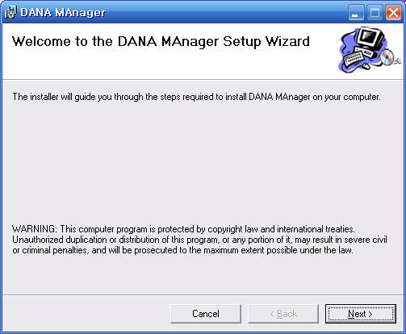 | Click “NEXT” button and start set up.
- Select set up folder
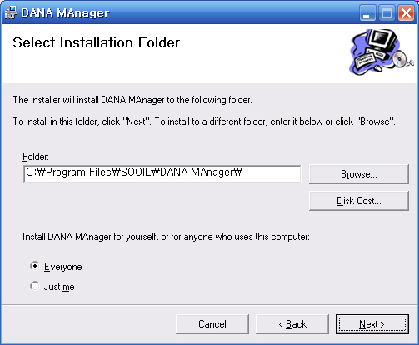 | Select folder where the installation program is to be installed and click “NEXT” button.

C. Installation
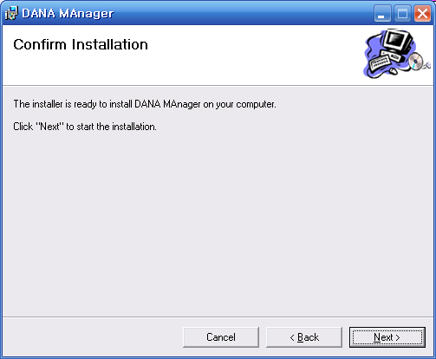 | When you have confirmed the install, click “NEXT” button to start installation.

- Set up DANA Monitor
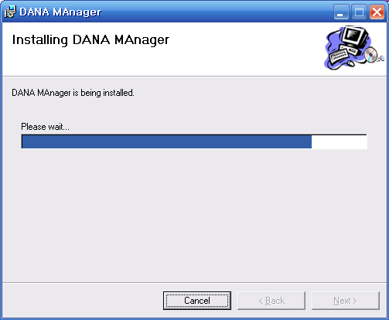 | Installation is being processed. Set up will take about 10-20 seconds.

- Installation Complete
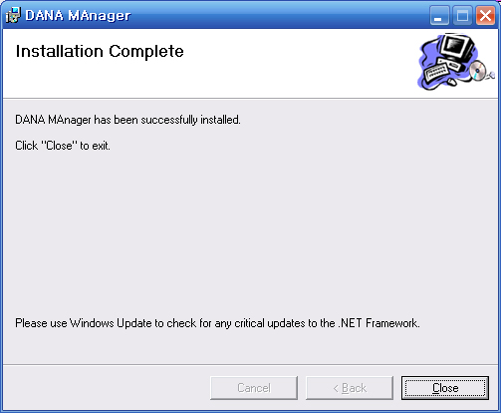 | When the program is been installed, click “ Close” button to finish the installation process.

- Setting up of Bluetooth connection
In the case of your PC not having Bluetooth built in, insert a Bluetooth dongle (contained in your pump kit) to a USB port of your PC or laptop.
Please refer to the Bluetooth user manual for detailed information of any Bluetooth device.
- Connection setting between PC and DANA insulin pump with Bluetooth
Connect PC and DANA insulin pump. This procedure is required at once for each following cases.
- At the first time of communication with the PC.
- In the case that the previous communication information in the PC was deleted.
1. Connection Process
- Execute ‘Bluetooth Unit’ and go to “Control Panel” in your PC. Find the Bluetooth icon and double click it.

- Add ‘Bluetooth Unit’
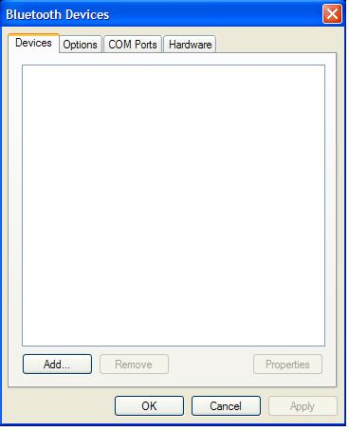 | Click ‘Add’ to add a new Bluetooth device to your list of connected Bluetooth devices.

- Set Discovery mode of DANA insulin pump
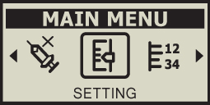  (figure 1)  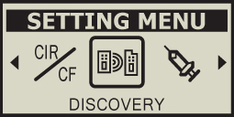  (figure 2)    (figure 3) | This is the procedure to keep the DANA pump waiting for communication with a bluetooth reciever.  a. In the MAIN MENU screen press N until the SETTING icon is  highlighted. Then press S. (figure 1)  b. The SETTING MENU screen will appear. Use N to highlight the DISCOVERY icon and press S (figure 2)  c. Discovery Icon blinks for 60 seconds (figure3)  d. Screen will be changed to initial display once changes saved.

- Inititate the Add Bluetooth Device Wizard
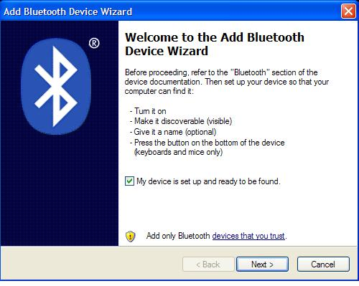 | Tick on ‘Unit set and ready to search’ and click ‘Next’ button.

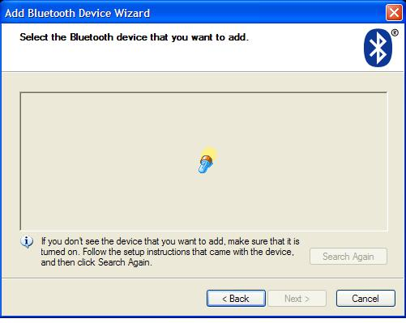 | Searching bluetooth takes about 10 -15 seconds.
- Search Unit

- Select Bluetooth Unit
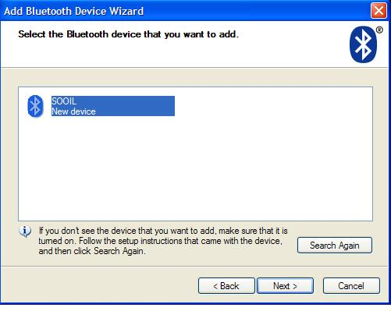 | Insulin pump will be listed as a serial number.  Add unit and click “NEXT” to continue.  * In case the device is not found, check your insulin pump for whether it is in discovery mode.  - Please note: Insulin pump and remote control must not be connected each other.

- PIN code Set up
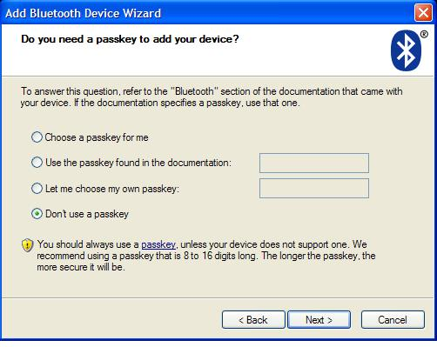 | Select ‘directly select PIN code’  Set the PIN code as ‘0000’.  * In case ‘no PIN code use’ is selected, this browser will be displayed again. The PIN code must be set.

- Complete Adding Bluetooth Unit
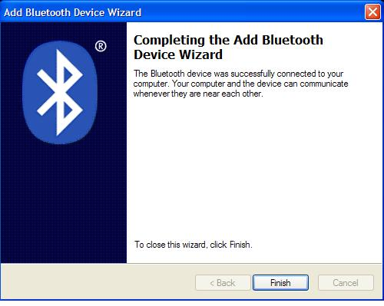 | Add bluetooth unit completed.  Memorise the outgoing COM port name.  Click ‘Done’ to finish.

[Note] COM Port Check
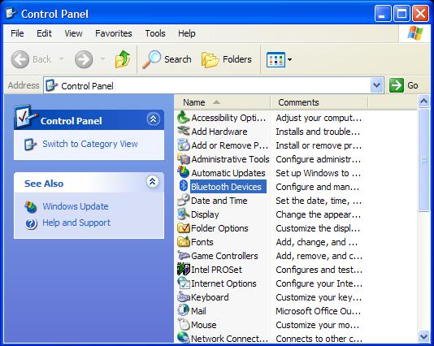 | Doublecheck COM port name.  In case the com port was not memorised, double click bluetooth unit in the Control Panel to check the outgoing COM port.  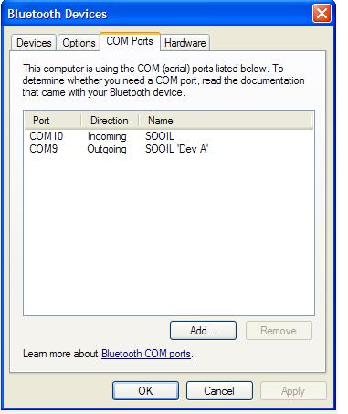
Chapter3. Function

- Registration

- Registration Process
- Click DANA Monitor Icon to start it up.
- You will see a small pop-up window in the middle of the initial screen.
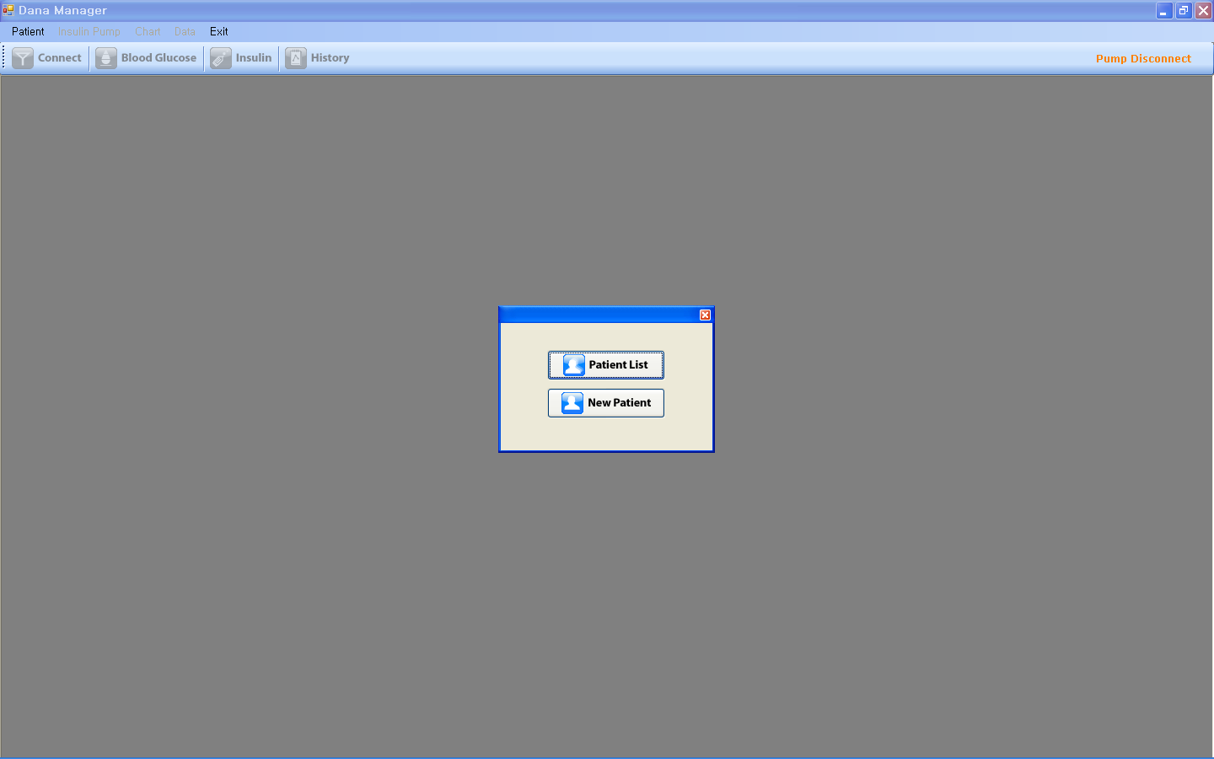

- Please choose between “Patient List” and “New Patient”
- If you choose “New Patient” you will see the screen below and should fill in the required information.
- Serial No should be e.g. “AAA00000AA” using all capital letters
- Input Port number (For example “COM15” this is the outgoing comport name you noted earlier)
- Input the patient’s name

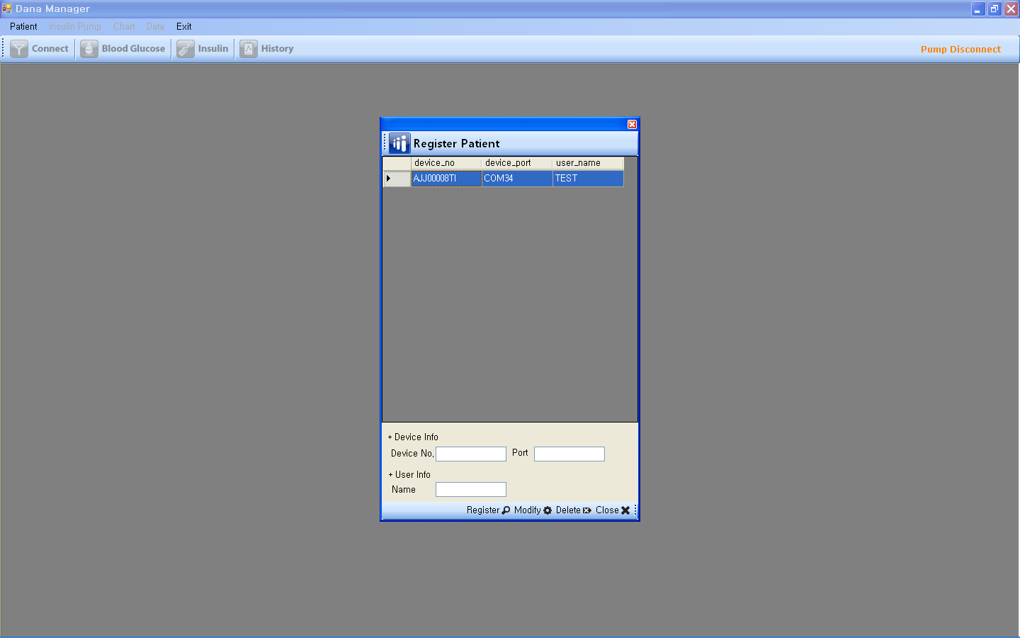

- If you choose “Patient List” please select one of the patient lists.
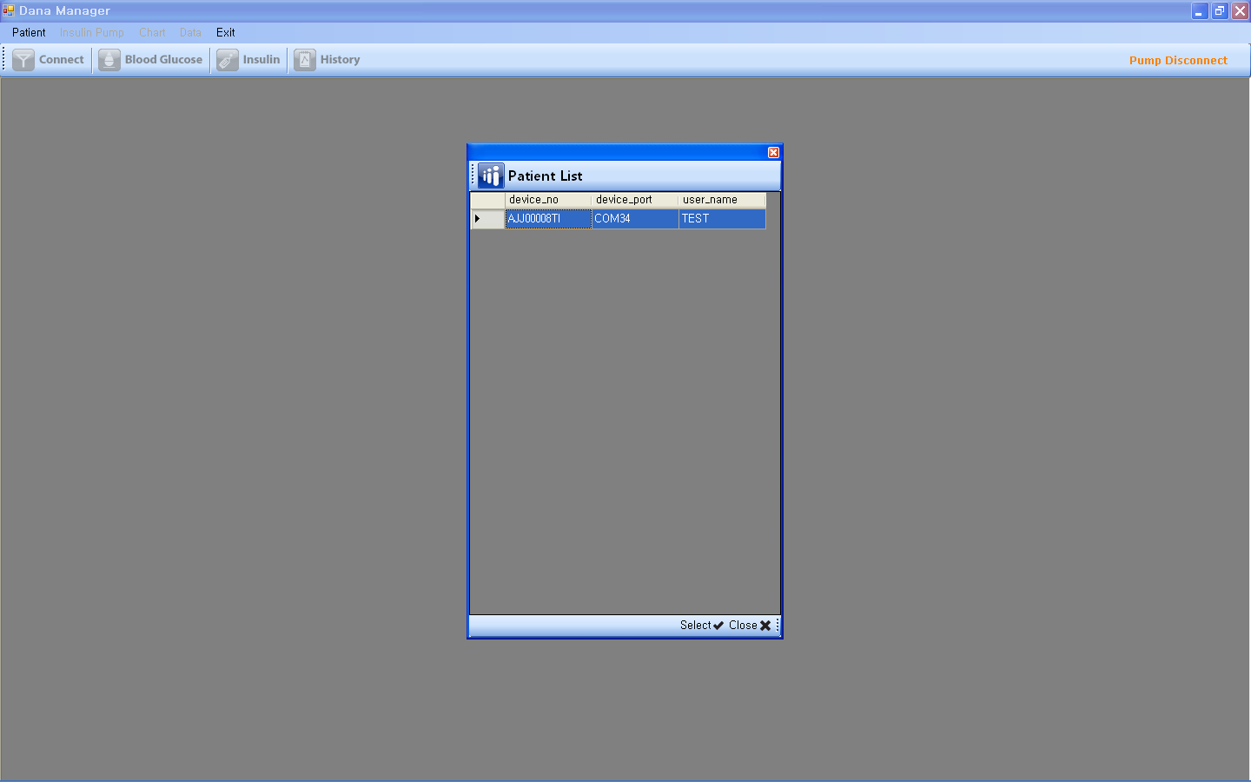

- Connection

- Connection Process
- If you select a patient, you will see the screen below. You can find patient name and serial number in the sub menu bar.
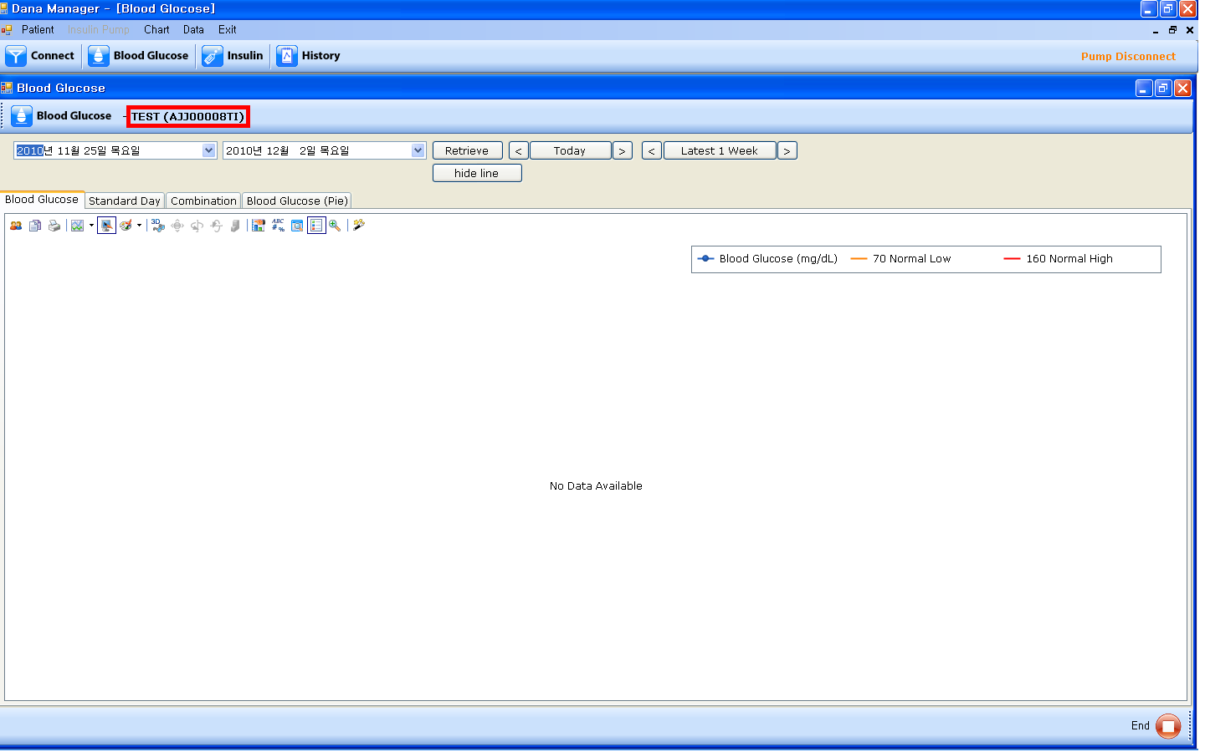

- Please click “Connect” icon. Then your pc and the pump will be connected wirelessly and download the data from the pump to your pc automatically.

- Blood Glucose
- Blood Glucose
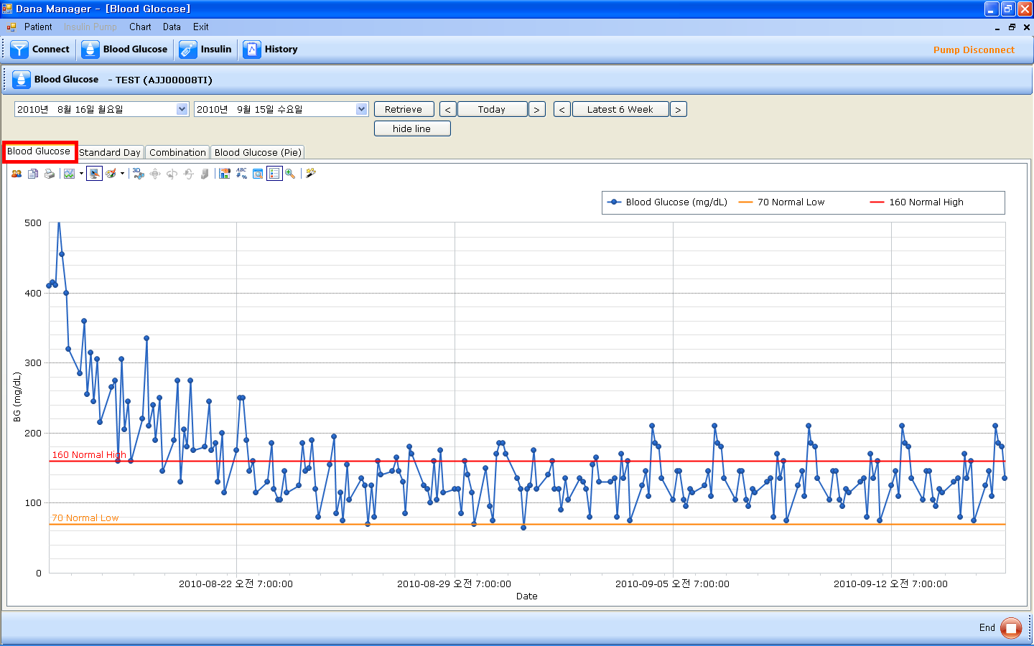

- Blue spots and lines are the blood glucose levels of the patient.
- If you put your mouse pointer on a spot, you will find the detailed information like date, time, and exact blood glucose level.
- You can fine two parallel lines in the screen. One is normal high value line and the other is normal low value line. If you want to change the values of normal high, and normal low, please see Chapter4. MENU BAR > II. Insulin Pump > 4. Setting > C. Normal BG Setting.
- You can adjust the value of them in the “Insulin Pump” menu on the menu bar “Insulin Pump > Setting > Normal BG Setting”. “Insulin Pump” menu is activated when the pump is being connected to your PC.
- You can set the time period by manual or using “Today”, “Last Week”.

- Standard Day
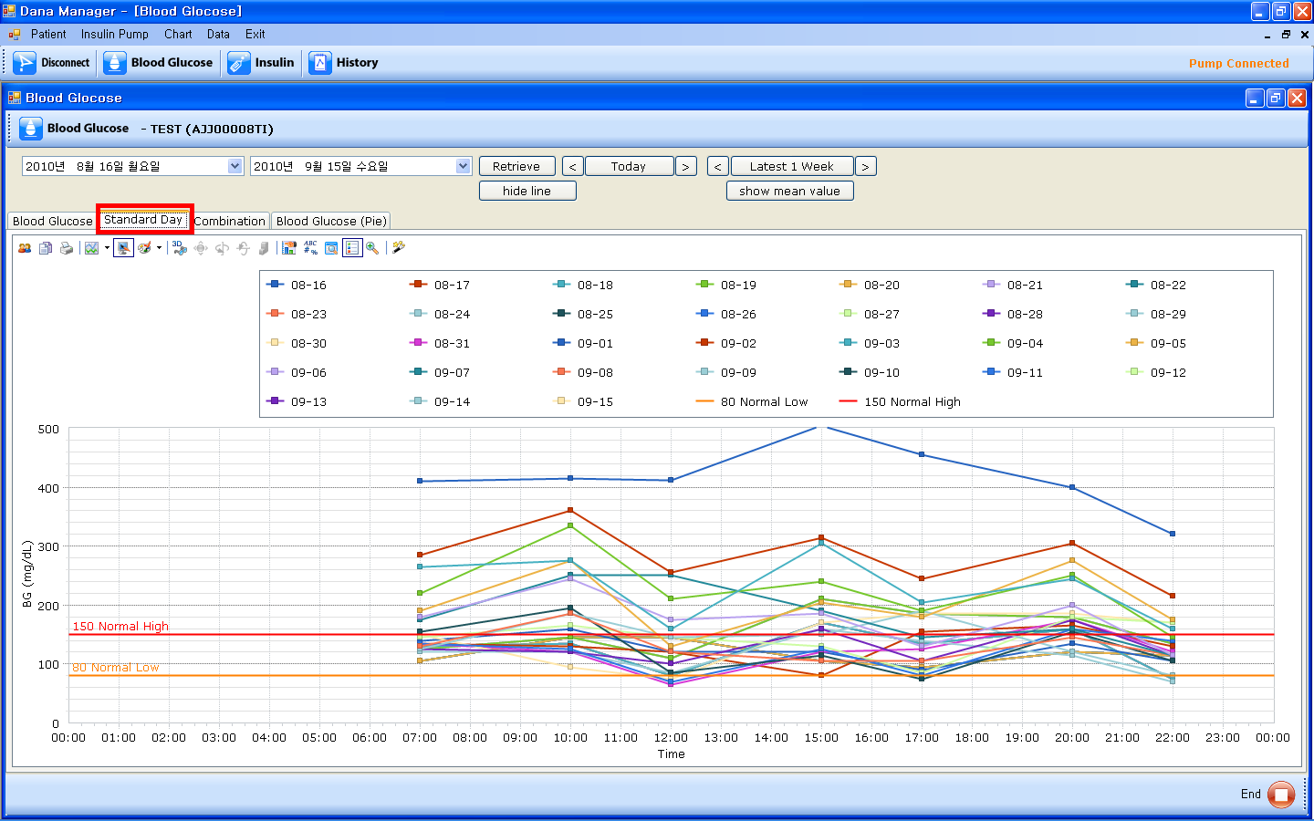

- A chart for the evaluation of the change of blood glucose levels by time.
- If you put your mouse pointer on a spot, you will find the detailed information like date, time, and exact blood glucose level.
- If you put your mouse pointer on the specific date in the table, you can see the graph of blood glucose for that specific date only.

- Combination
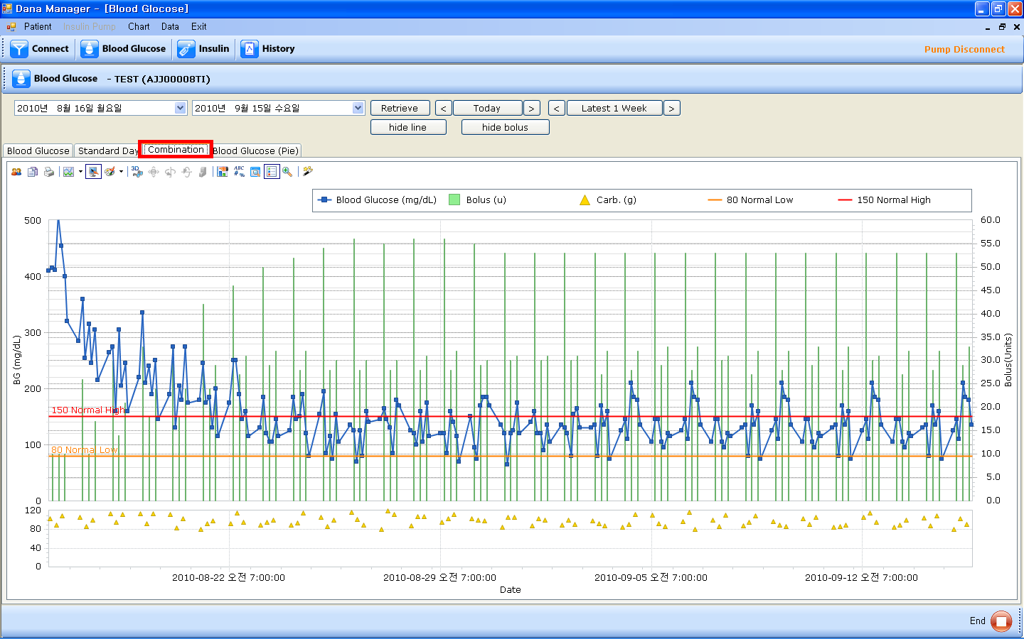

- A combination chart of Blood Glucose, Bolus insulin amount, and carbohydrate amount.
- If you put your mouse pointer on a spot or a line, you will find the detailed information of blood glucose level, bolus amount, and carbohydrate amount with time and date information.
- If you put your mouse pointer on the specific item in the table, you can see the graph for that specific item only.
- Time values are on X-axis, Blood Glucose Values are on the left Y-axis, and Bolus values are on the right Y-axis

- Blood Glucose(Pie)
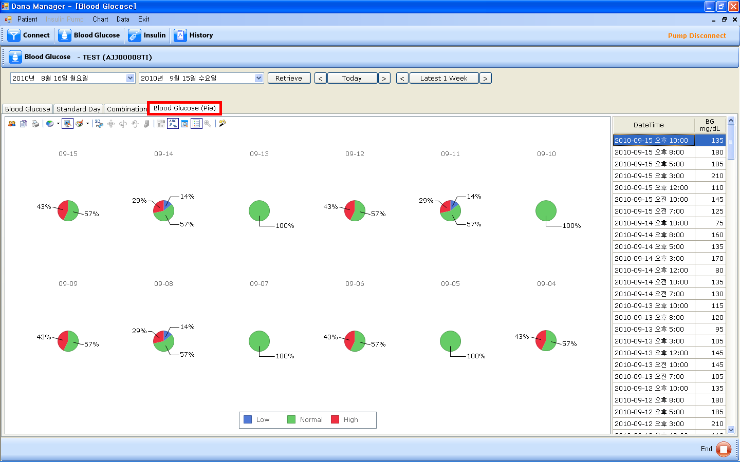

- A pie chart for blood glucose levels which are classified according to Low value, Normal value, and High value.
- You can adjust the value for Low, Normal, and High in the “Insulin Pump” menu on the menu bar “Insulin Pump > Setting > Normal BG Setting”. “Insulin Pump” menu is activated when the pump is being connected to your PC.
- If you put your mouse pointer on the specific value in the table, you can see the graph for that specific value only.

- Insulin
- Daily Total Dose
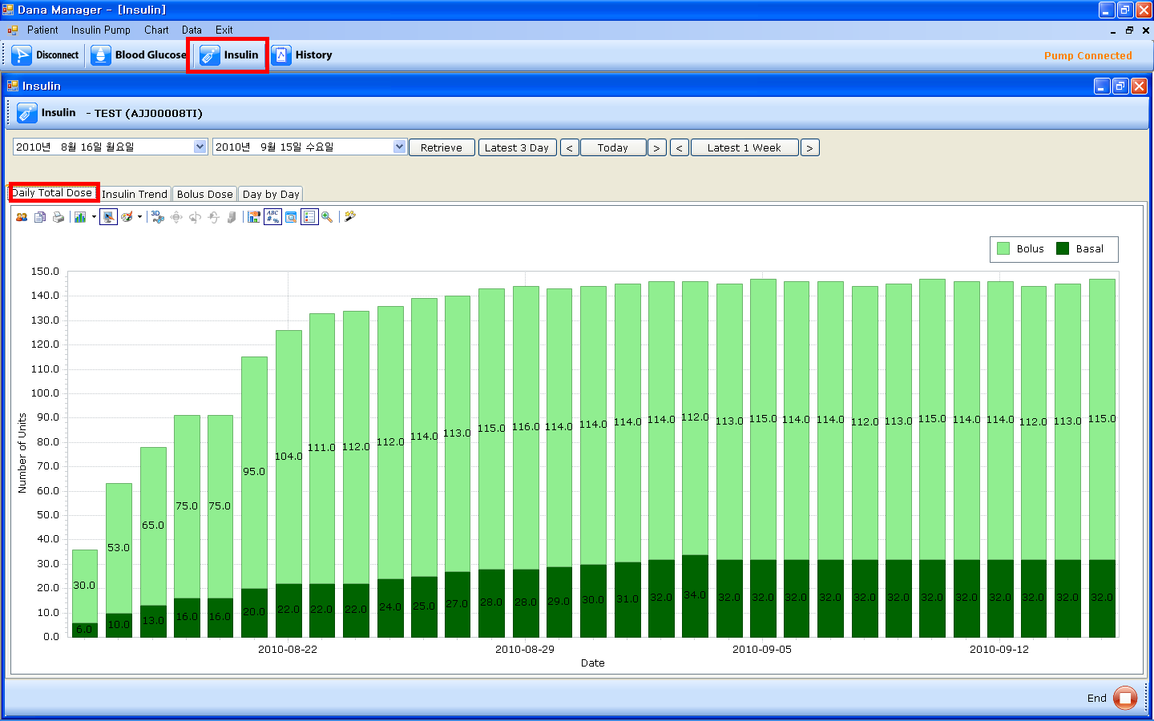
- A bar chart of the total insulin amount divided into Bolus and Basal.
- If you put your mouse pointer on a specific bar, you will find the exact daily total insulin amount on that day.
- If you put your mouse pointer on the specific value in the table, you can see the graph for that specific value only.

- Insulin Trend
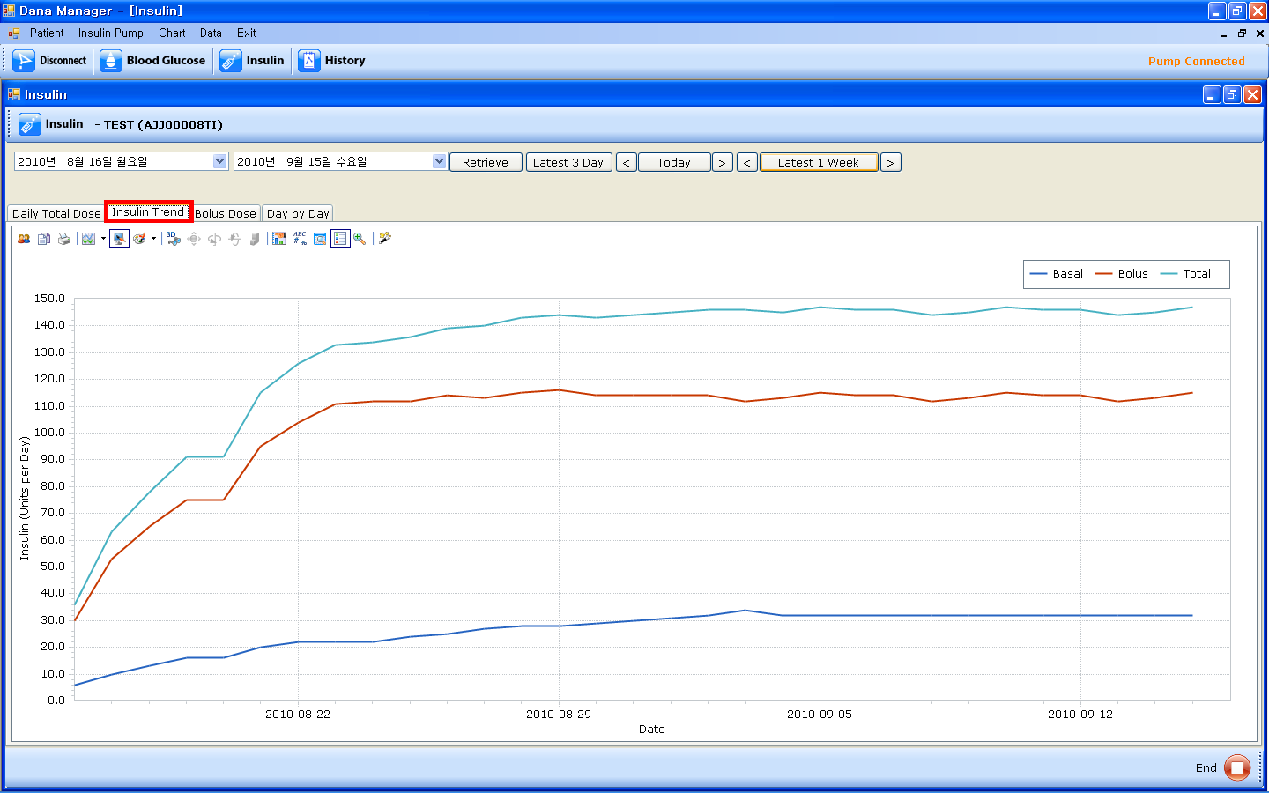

- The line charts of Basal insulin amount, Bolus insulin amount, and Daily total insulin amount.
- If you put your mouse pointer on the specific value in the table, you can see the chart for that specific value only.
- If you put your mouse pointer on the specific line chart, you can see the specific information.

- Bolus Dose
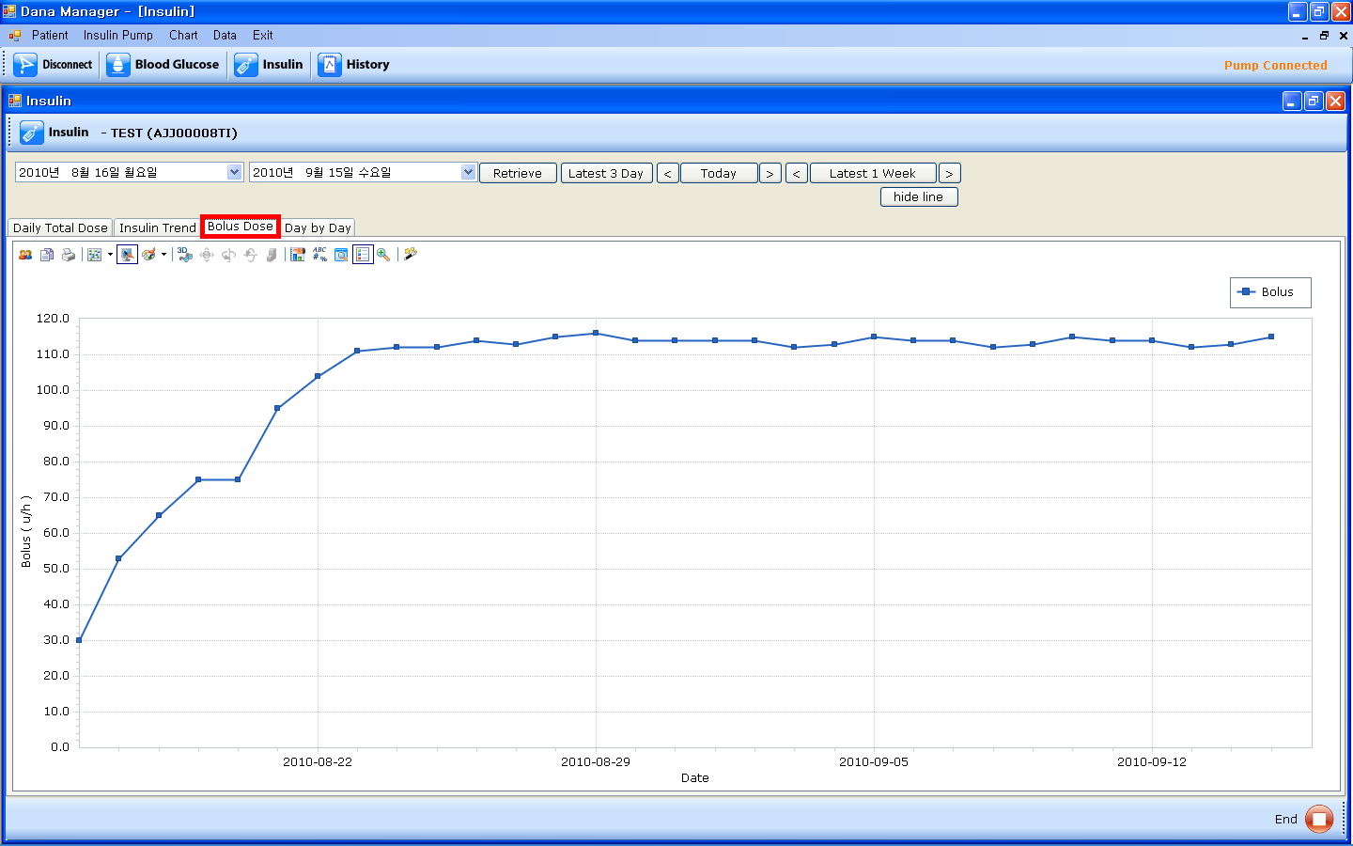

- A line chart of meal bolus insulin amount.

- Day by Day
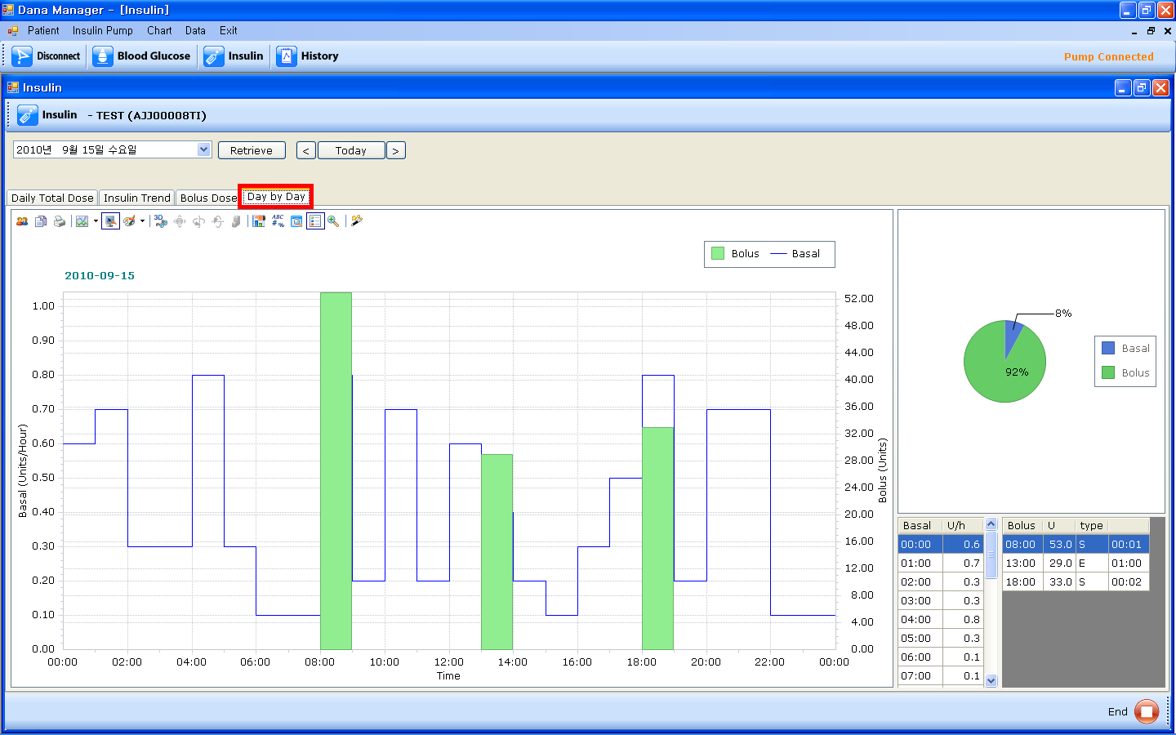
- A combination chart of meal bolus amount and basal insulin amount in a specific day.
- Time values are on X-axis, basal insulin values are on the left Y-axis, and meal bolus values are on the right Y-axis.
- If you put your mouse pointer on the specific value in the table, you can see the chart for that specific value only.
- You can see a pie chart which shows the percentage of basal insulin and bolus insulin out of daily total insulin amount.
- You can also find the detailed tables of basal insulin and meal bolus insulin.

- History

- Alarms
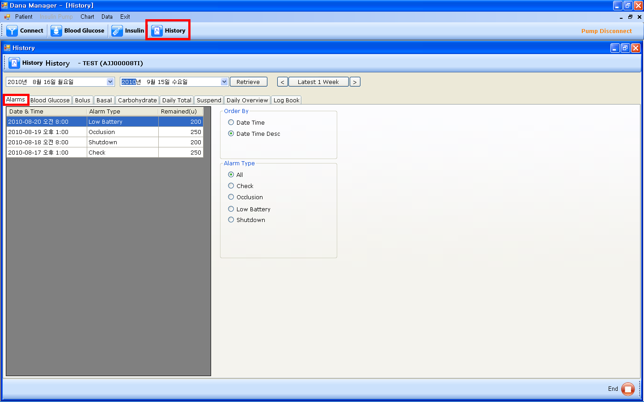

- You can find the history of Check, Occlusion, Low Battery, Shutdown alarms in this menu.
- If you choose “Date Time” in the Order by table, alarms histories will be sorted by date and time in ascending order. If you choose “Date Time Desc”, alarms histories will be sorted by date and time in descending order.
- If you choose a specific value in the Alarm Type table, you can see the specific values which you have chosen.

- Blood Glucose
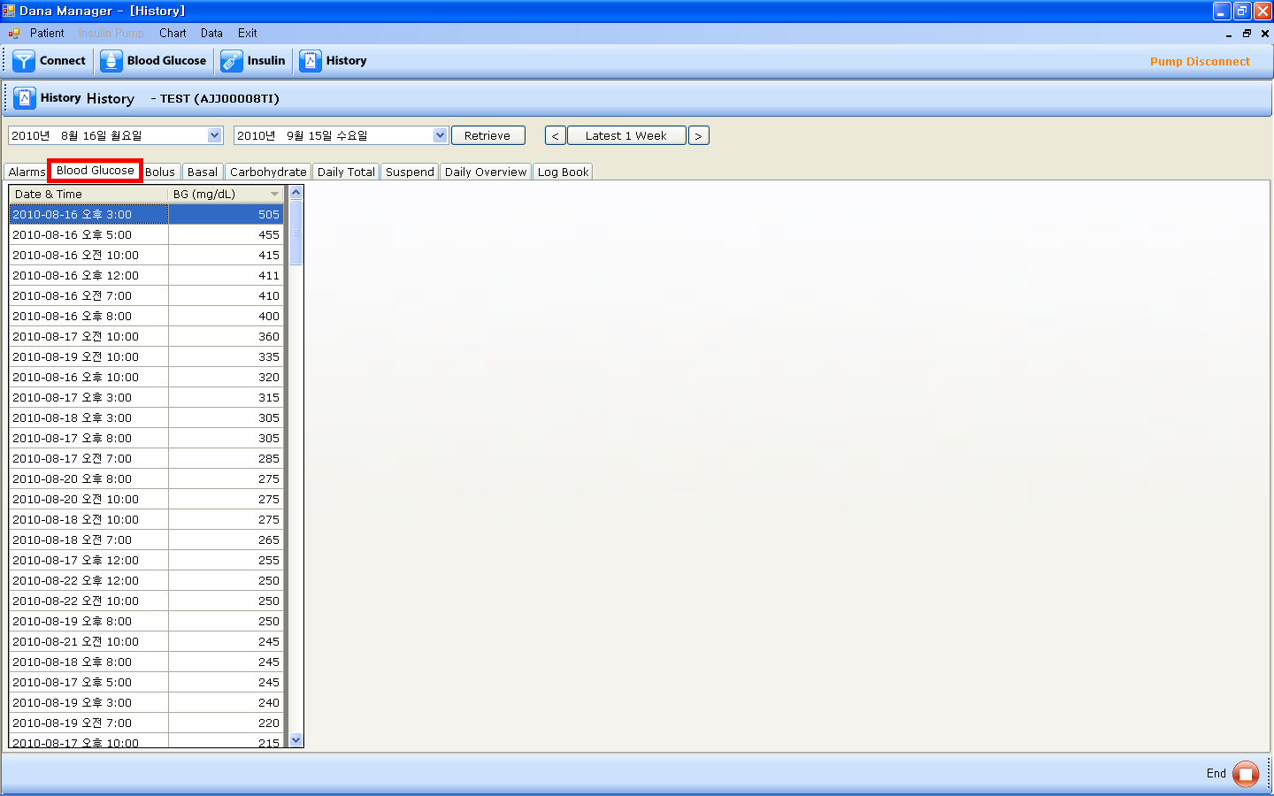

- A history table of blood glucose levels.
- If you click “Date & Time” on the top of the table, the data will be sorted by date and time in descending order.
- If you click “BG”, the data will be sorted by glucose levels in descending order.

- Bolus
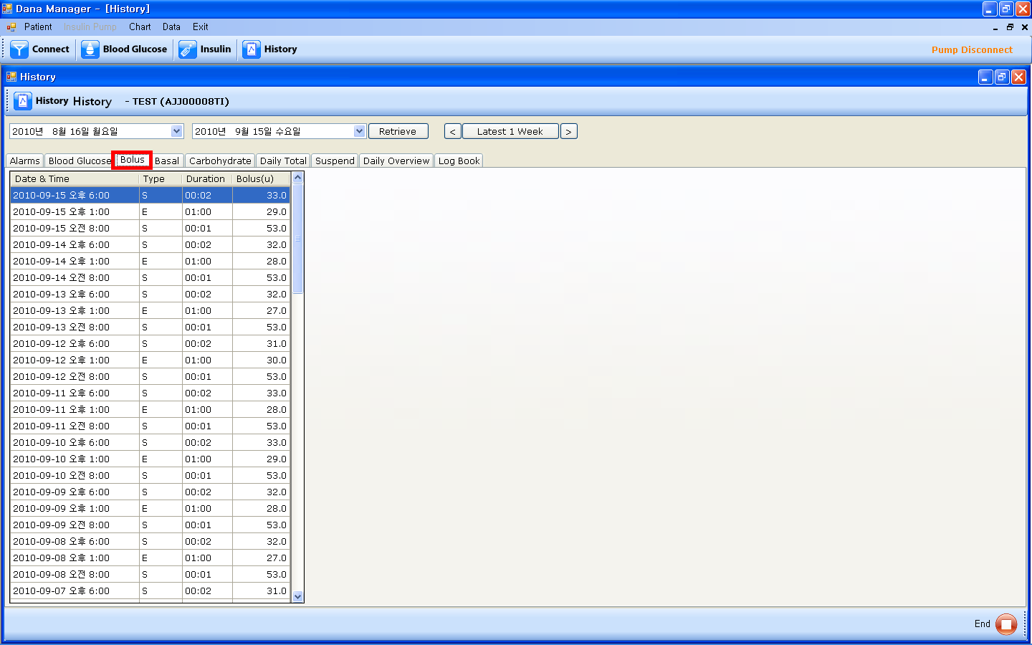

- A history table of meal bolus.
- If you click “Date & Time” on the top of the table, the data will be sorted by date and time in descending order.
- If you click “Type”, the data will be sorted by meal bolus type.
- If you click “Duration”, the data will be sorted by duration of meal bolus in descending order.
- If you click “Bolus (U)”, the data will be sorted by insulin amount in descending order.

- Basal
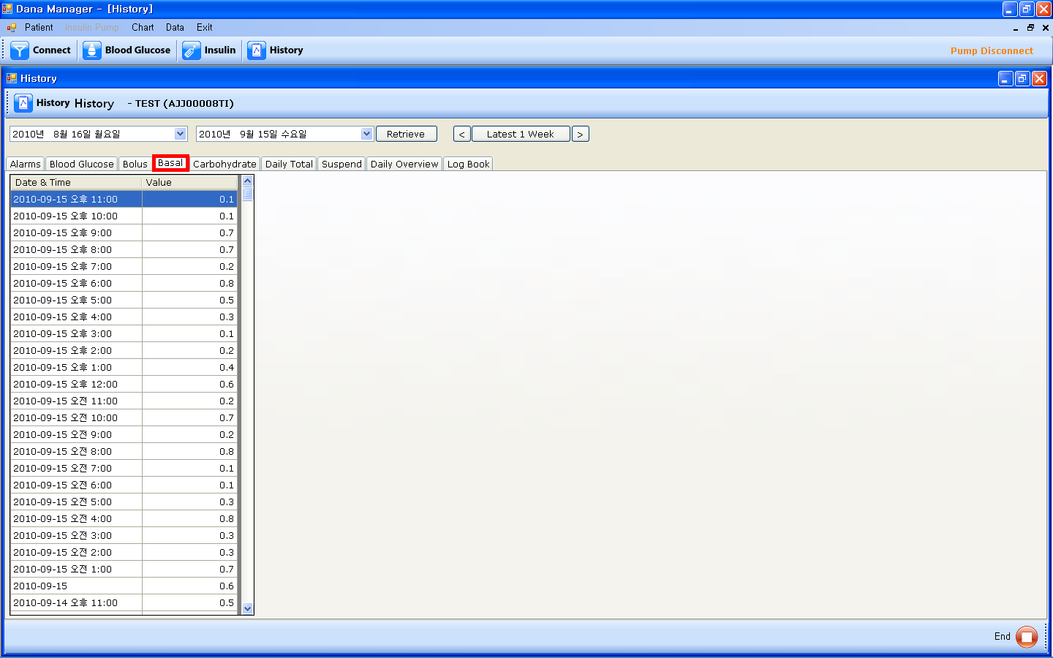

- A history table of hourly basal insulin amount.
- If you click “Date & Time” on the top of the table, the data will be sorted by date and time in descending order.
- If you click “Value”, the data will be sorted by basal insulin amount in descending order.

- Carbohydrate
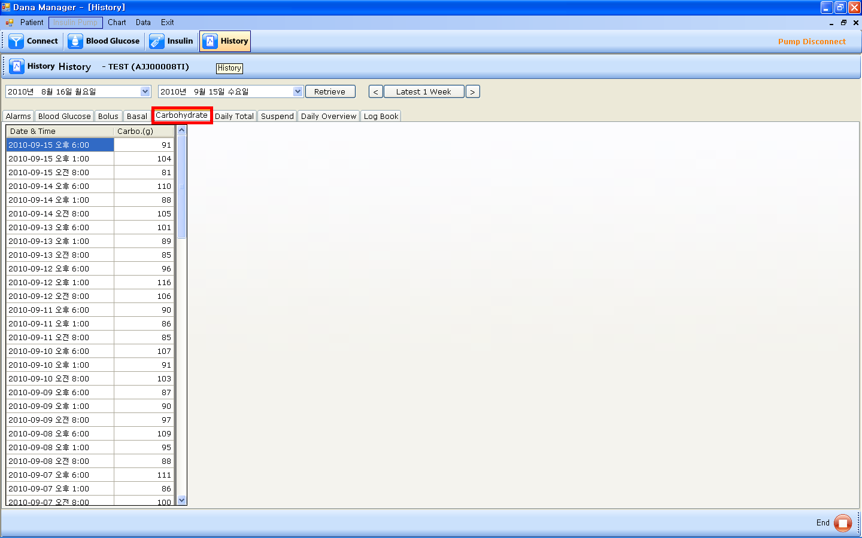

- A history table of carbohydrate amounts.
- If you click “Date & Time” on the top of the table, the data will be sorted by date and time in descending order.
- If you click “Carbo (g)”, the data will be sorted by basal insulin amount in descending order.

- Daily Total
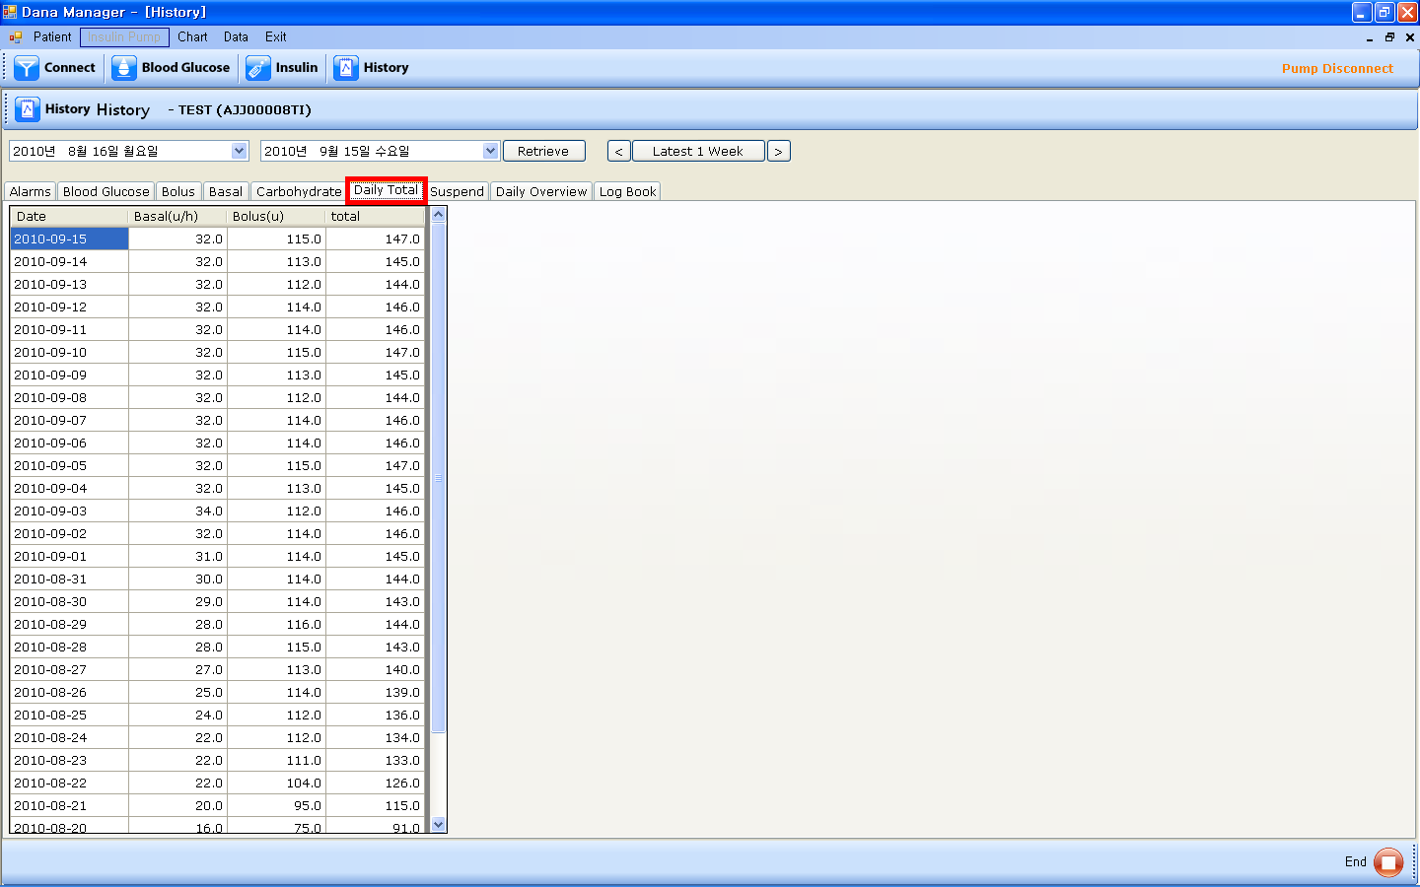

- A history table of the daily total insulin amount delivered. You can find the daily total amount of basal insulin, daily total amount of meal bolus insulin, and daily total insulin amount.
- If you click “Date & Time” on the top of the table, the data will be sorted by date and time in descending order.
- If you click “Basal(u/h)”, the data will be sorted by total basal insulin amount in descending order.
- If you click “Bolus(u)”, the data will be sorted by total bolus insulin amount in descending order.
- If you click “Total”, the data will be sorted by daily total insulin amount in descending order.

- Suspend
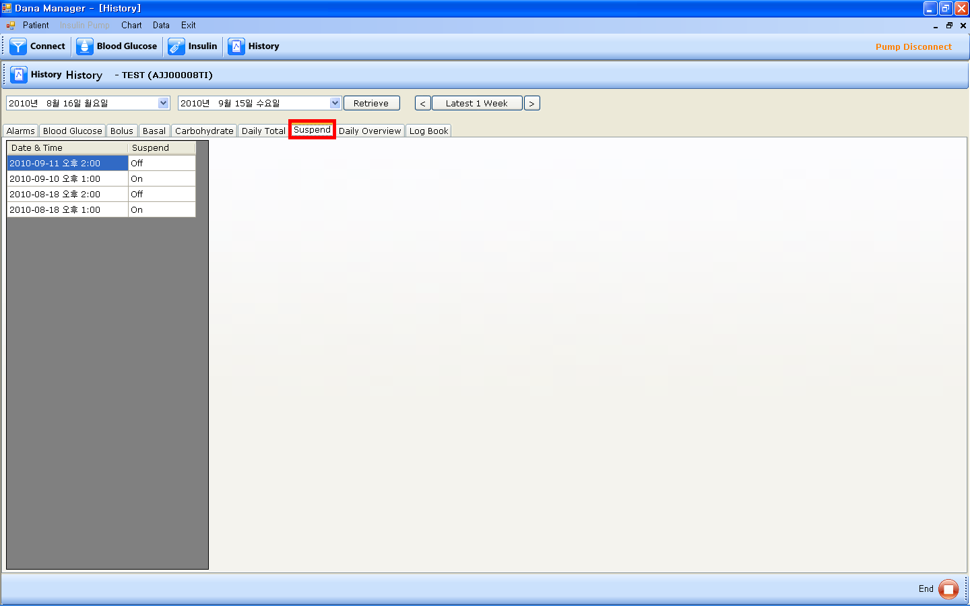

- A history table of the time of suspend function is on or off.
- If you click “Date & Time” on the top of the table, the data will be sorted by date and time in descending order.

- Daily Overview
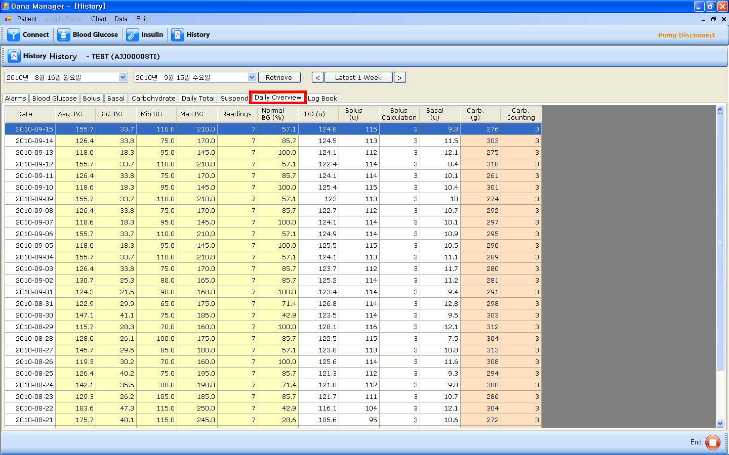

- A table of daily summary of key factors.
- If you click “Date & Time” on the top of the table, the data will be sorted by date and time in descending order.
- “Avg. BG” column is the average value of your BG check results on that day.
- “Std. BG” column is the standard deviation of BG on that day.
- “Min BG” column is the minimum value of the BG check results on that day.
- “Max BG” column is the maximum value of the BG check results on that day.
- “Readings” column is the times of BG check on that day.
- “Normal BG(%)” is the percentage of the number of times being in the normal BG range out of the number of the total BG check times on that day.
- “TDD(u)” column is the total daily doses of insulin delivered on that day.
- “Bolus(u)” is the total insulin amount of the meal bolus insulin delivered on that day.
- “Bolus Calculation” column is the number of bolus calculating times on that day.
- “Basal(u)” column is the total insulin amount of the basal insulin delivered on that day.
- “Carb.(g)” column is the total grams of carbohydrates on that day.
- “Carb. Counting” column is the number of carbohydrate counting times on that day.

- Log Book
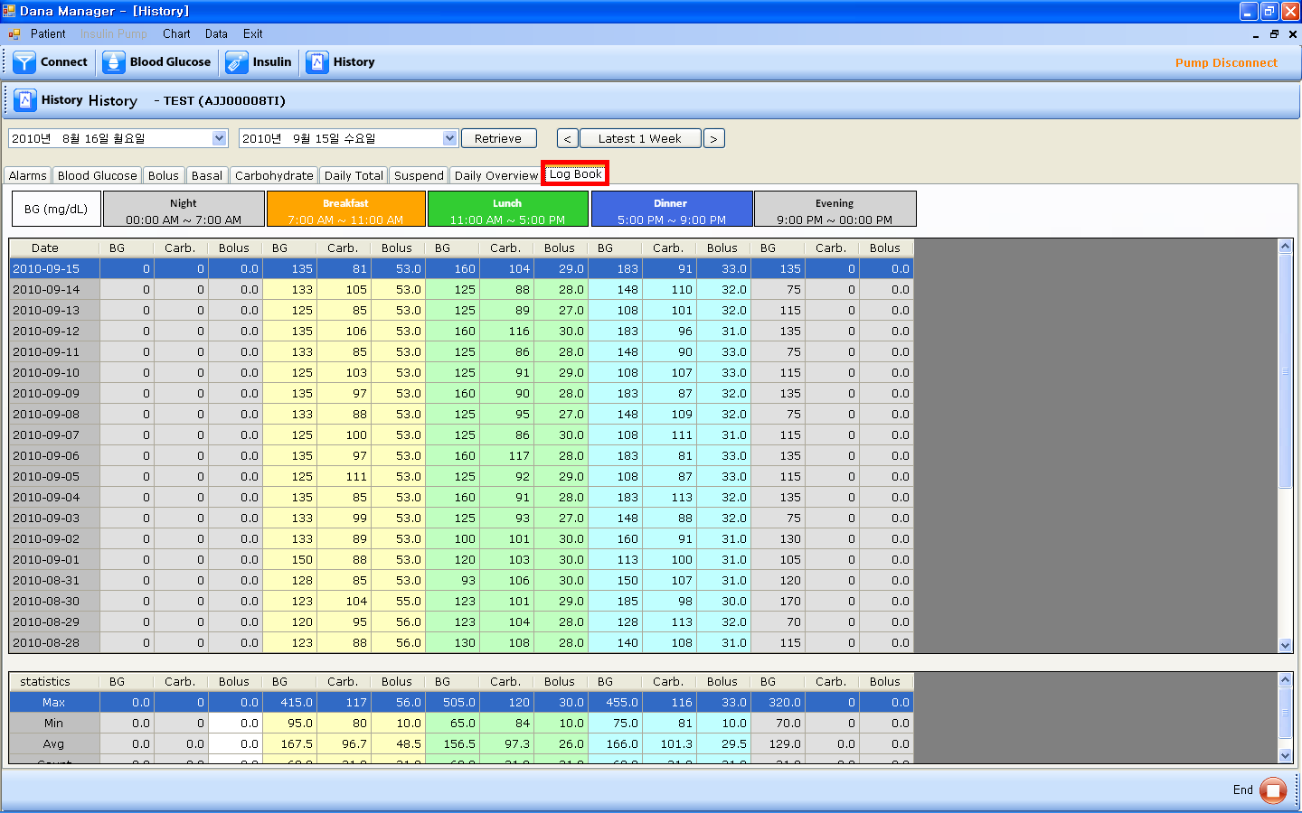

- A log book divided in the time periods of Night, Breakfast, Lunch, Dinner, and Evening.
- If you click “Date”, the data will be sorted by date in descending order.
- “BG” column is BG value during the time period. If you check your BG value more than one time in that time period, “BG” column shows the average of the BG values in that time period.
- “Carb.” column is the grams of carbohydrate in that time period.
- “Bolus” column is the meal bolus insulin delivered in that time period.
- Statistics table shows Minimum value, Maximum value, Average value and the number of count in each column in that time period.

Chapter4. MENU BAR

- Patient

- New
- If you click “New” in the “Patient” menu, a pop-up screen will be shown up. Please fill in the required information of Serial No, Port, and User Info.

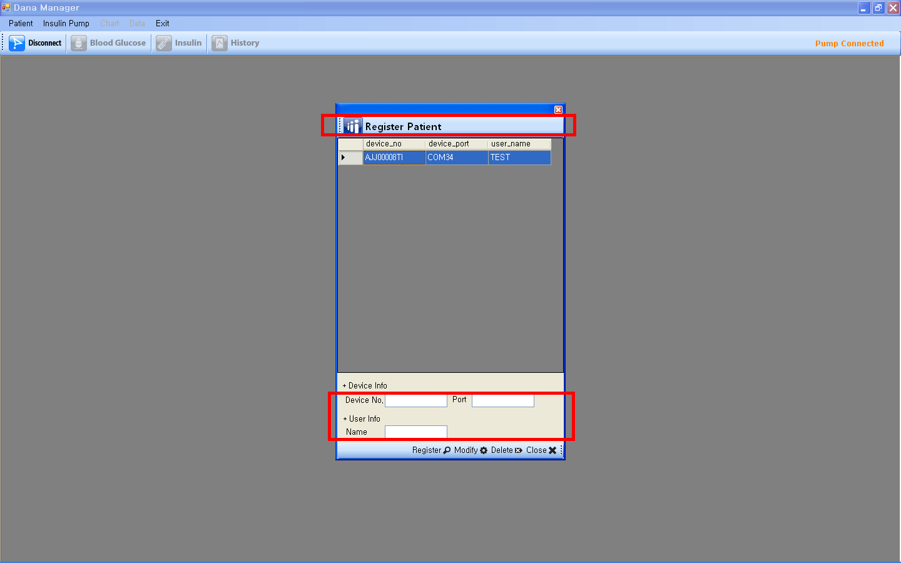

- List
- If you want to open the data of another patient, please click “List” and choose a patient and chick “Select” on the bottom.
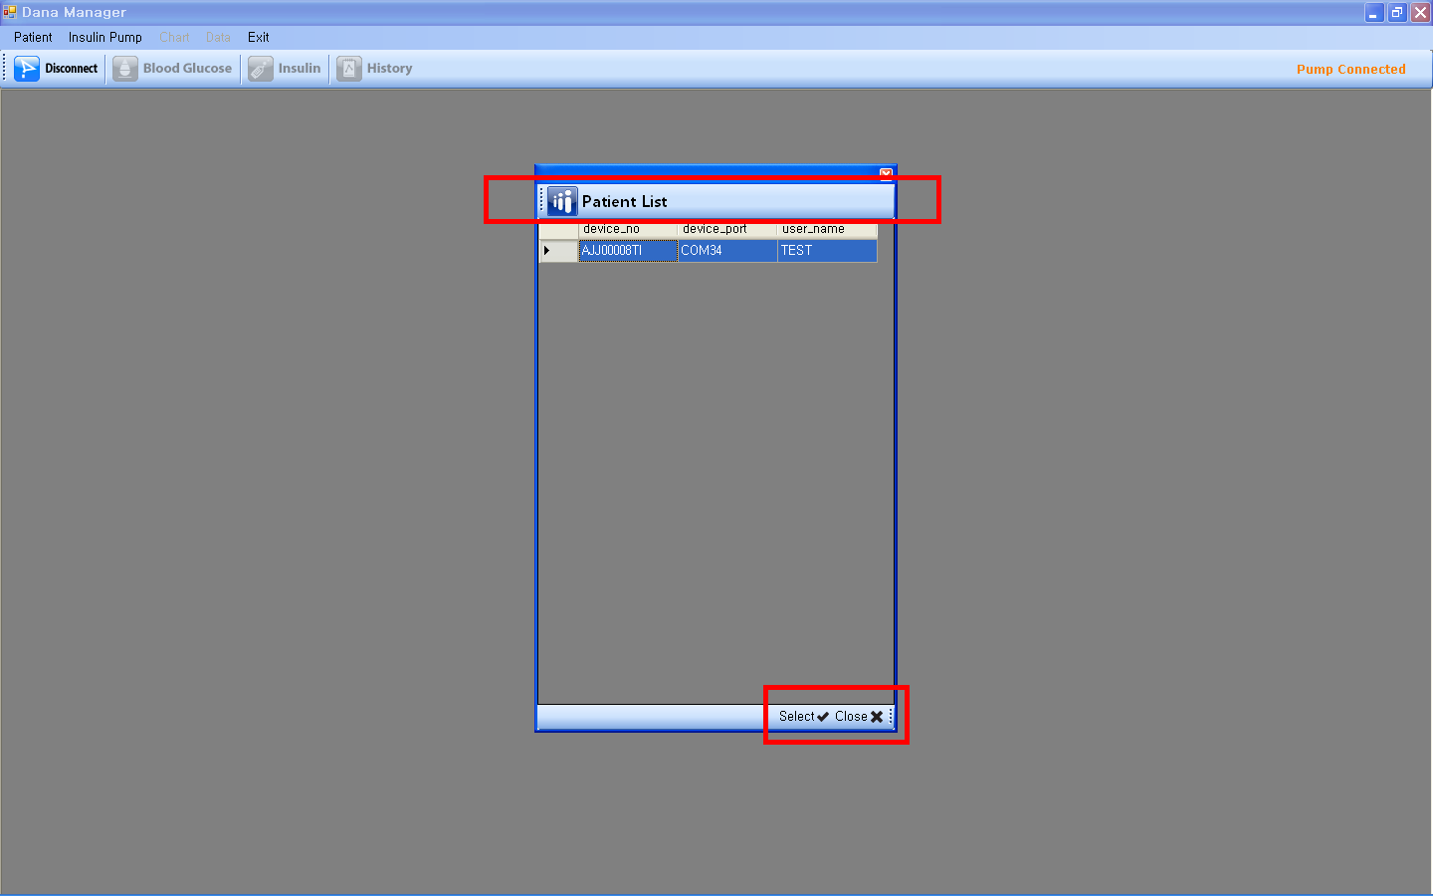

- Insulin Pump

“Insulin Pump” menu is activated only the pump is connected to your PC. If “Insulin Pump” menu is not activated, please click “Connect” icon.

- Disconnect
- If you want to disconnect the pump with your PC, please click “Disconnect” menu.

- History Download
- If you want to download new information from the pump, please click “History Download” menu and a pop-up screen will show up. Please click “Download” on the bottom to start this feature.
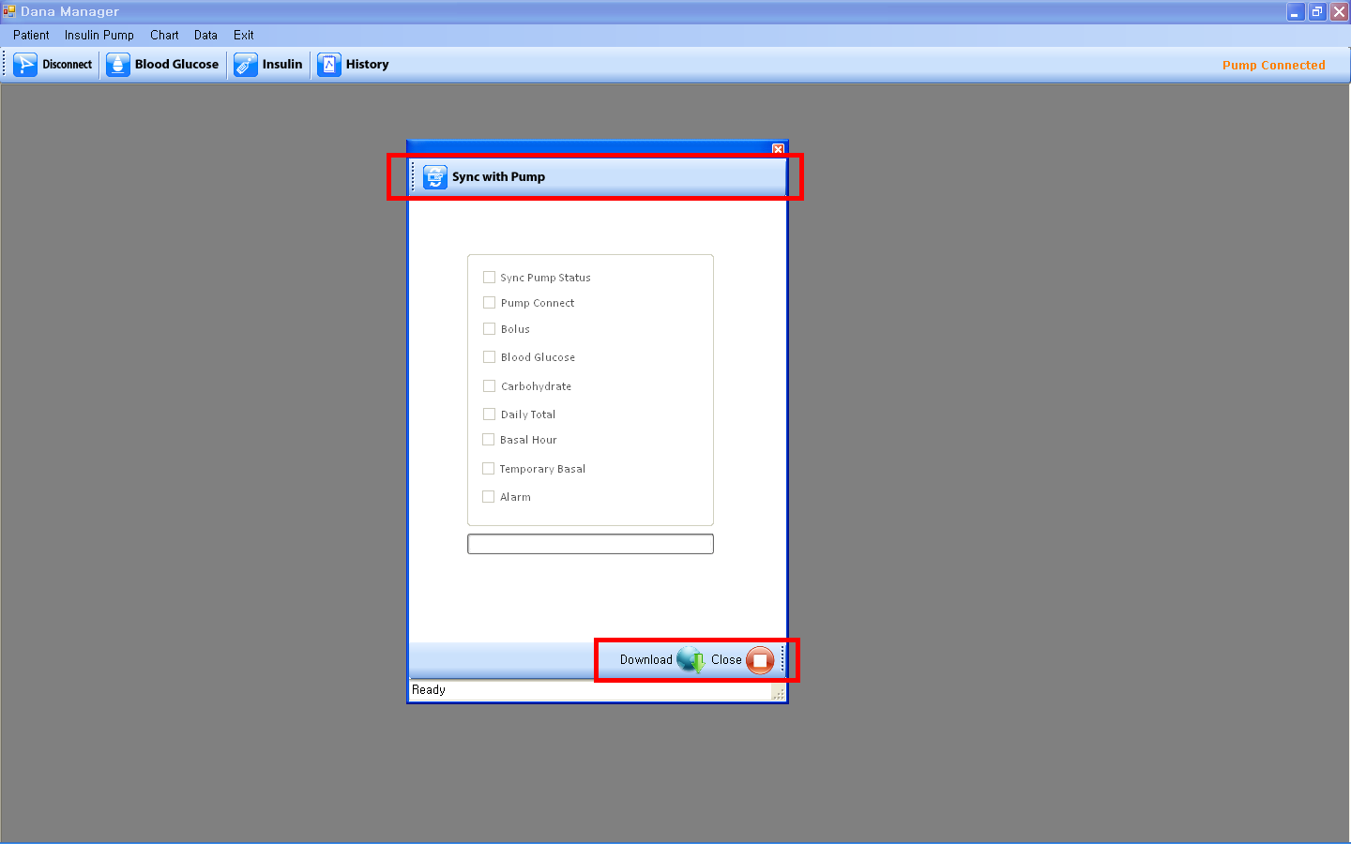

- Pump Status
- If you want to check the information regarding the pump, please click “Pump Status” menu and a pop-up screen will show up. You can find remained insulin, current time, total daily dose delivered today, basal dose, serial number, country name, and date.
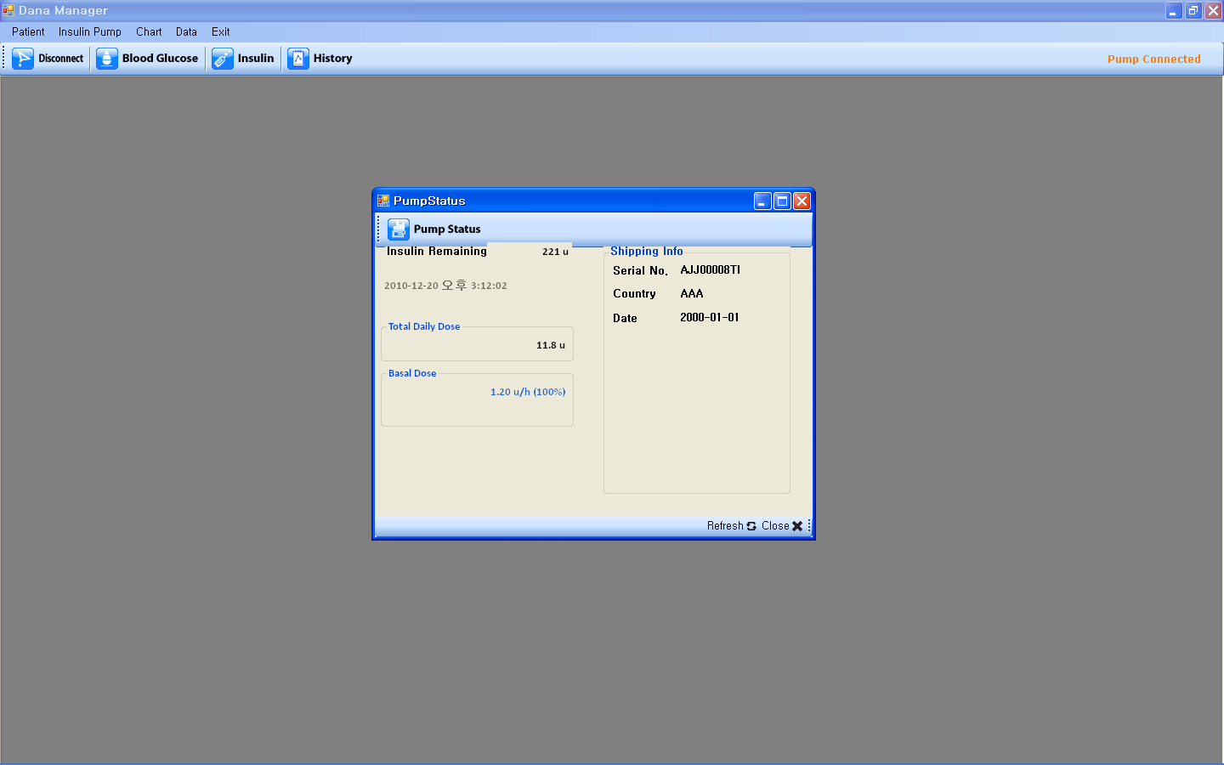

- Setting
- Bolus Setting
- If you click “Bolus Setting” menu, Setting Bolus screen will show up. You can set the insulin amount of the preset bolus.
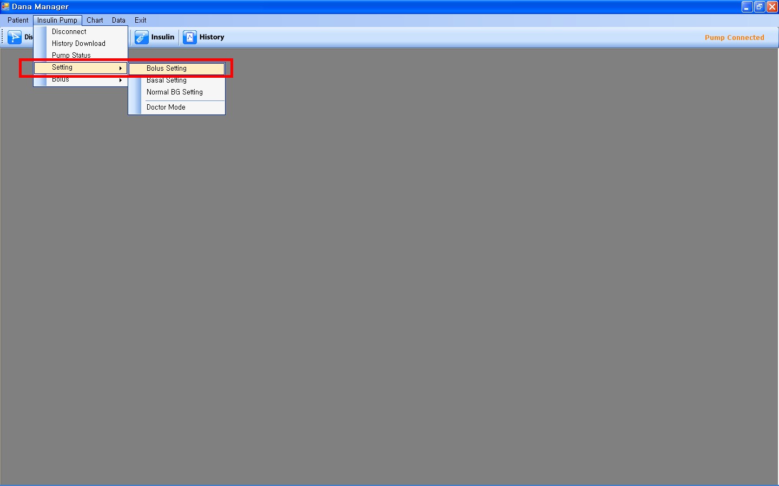
- Once you adjust the amount, please click “Apply” on the bottom to save it.
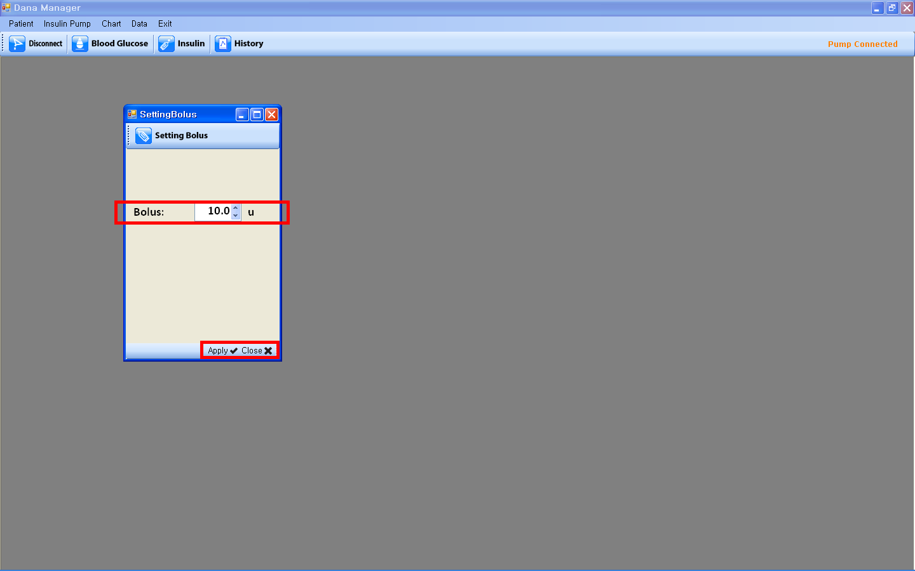

- Basal Setting
- If you click “Basal Setting”, Setting Basal screen will show up.
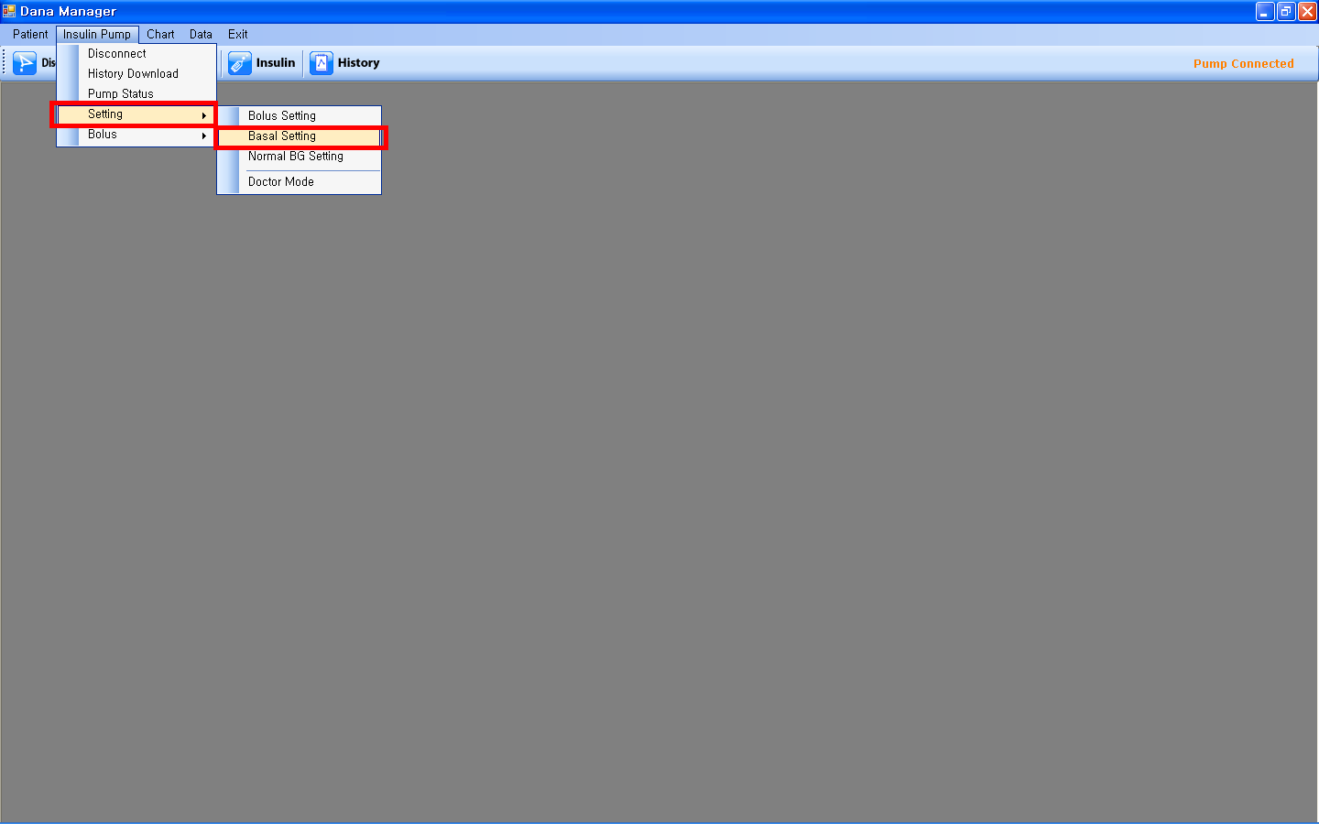

- Please select profile number on the top first and then adjust the basal insulin amount hourly. Please click “Apply” on the bottom to save it.
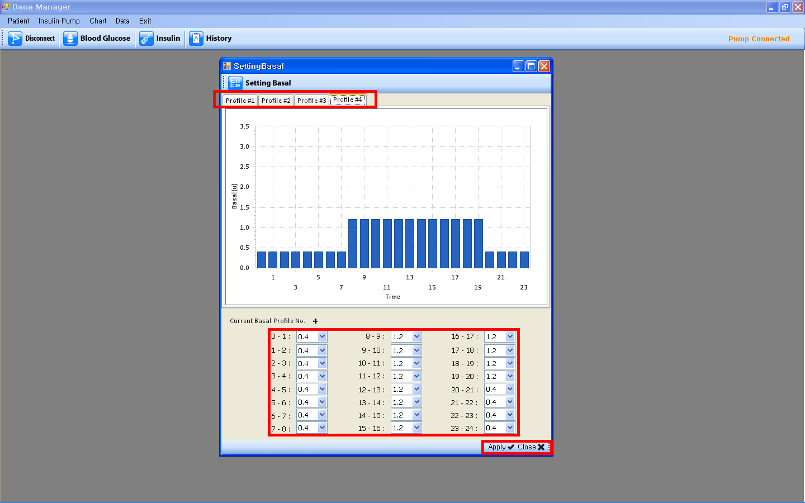

- Normal BG Setting
- If you click “Normal BG Setting”, BG Zone screen will show up.
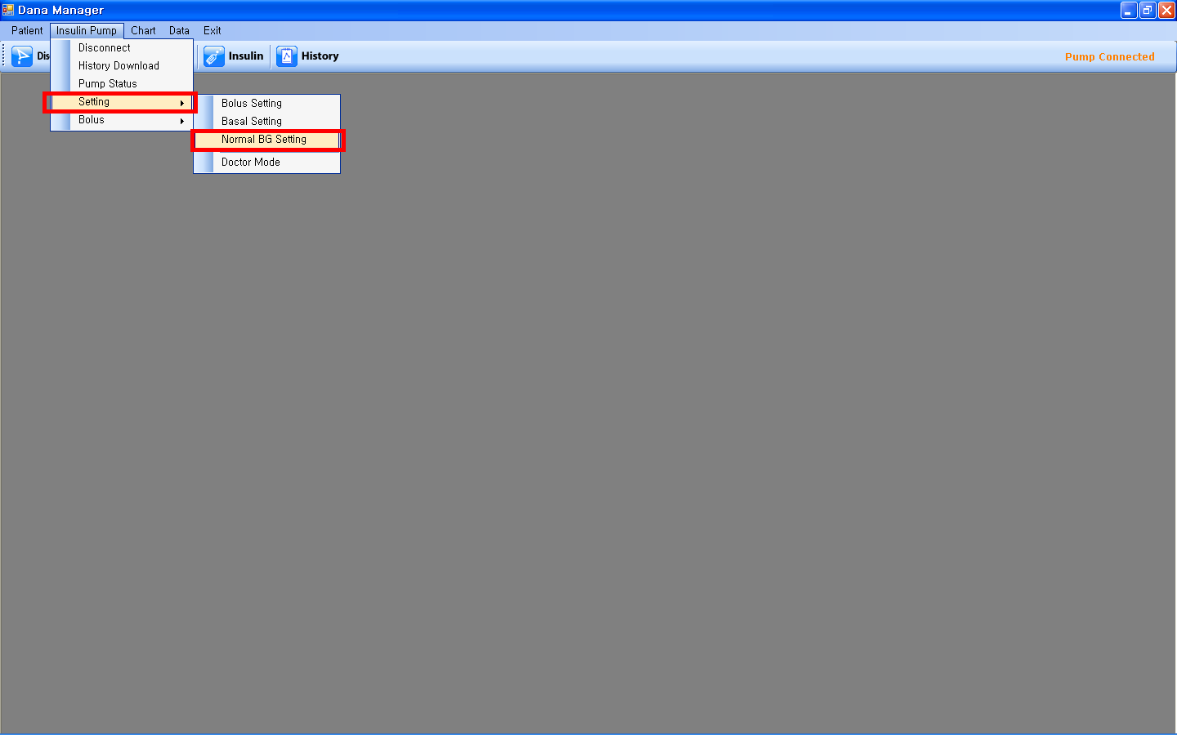
- Please adjust the values of Normal High and Normal Low and click the “Apply” on the bottom to save it.
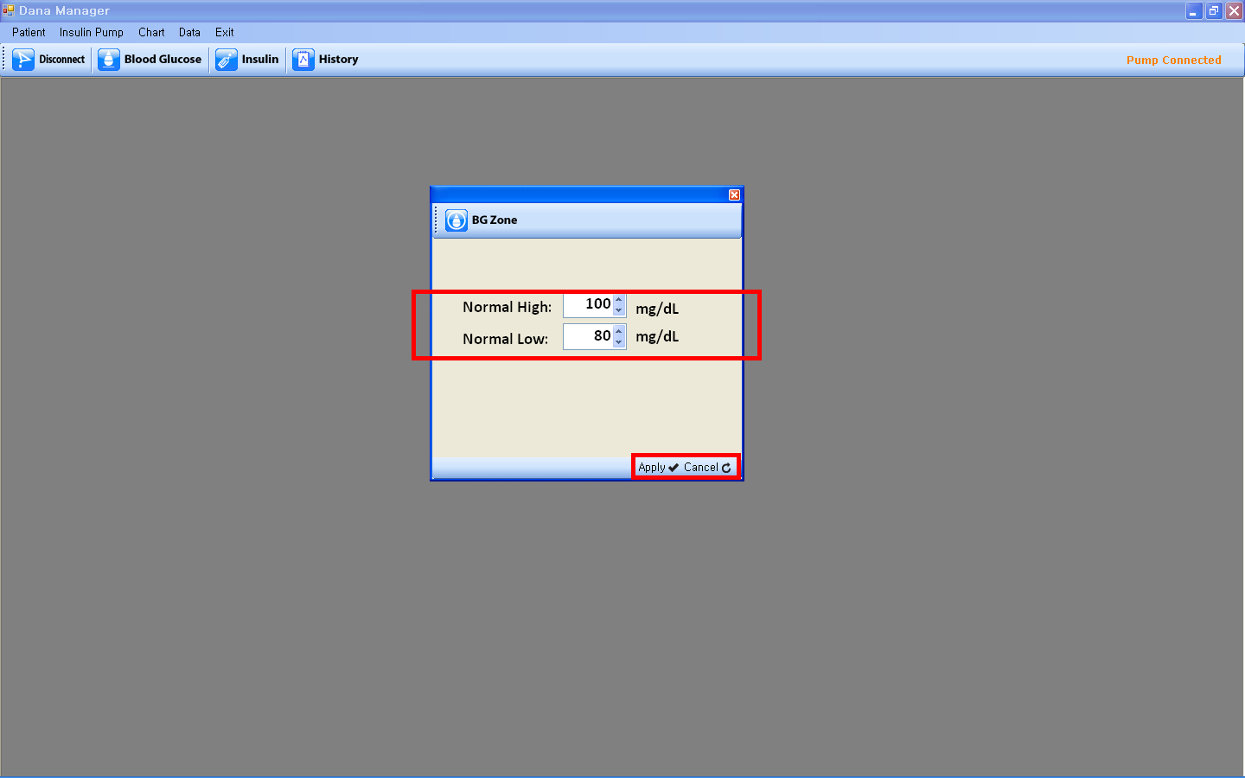

- Bolus
- Bolus
- If you click “Bolus” menu,
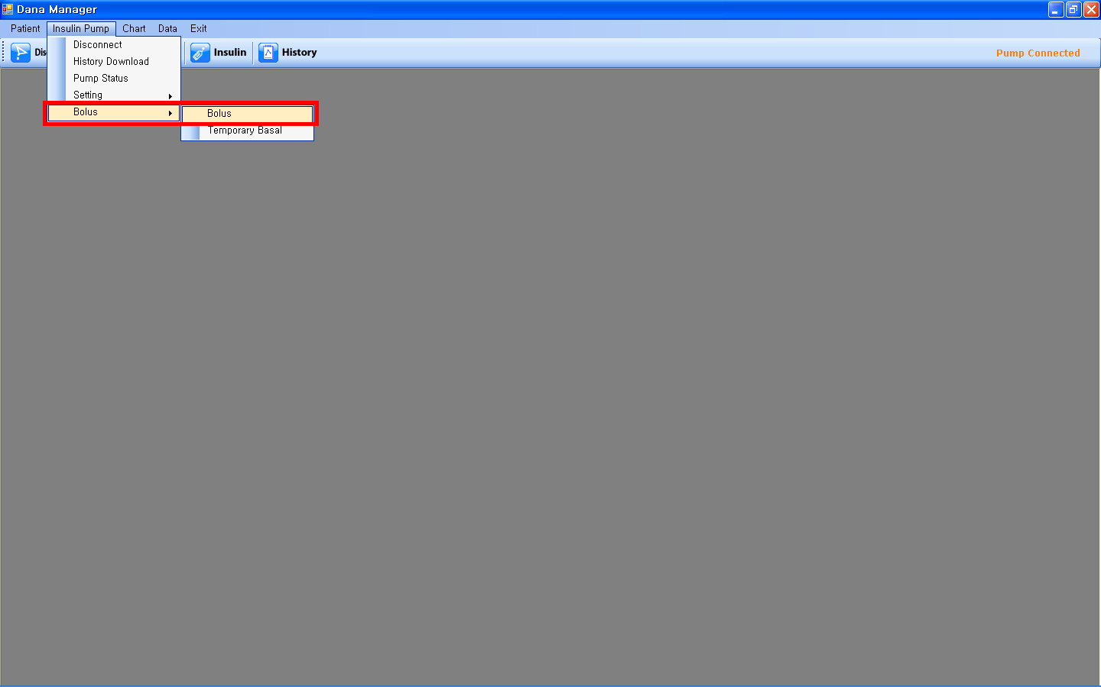

- Please fill in the required information to calculate the suggested bolus insulin.
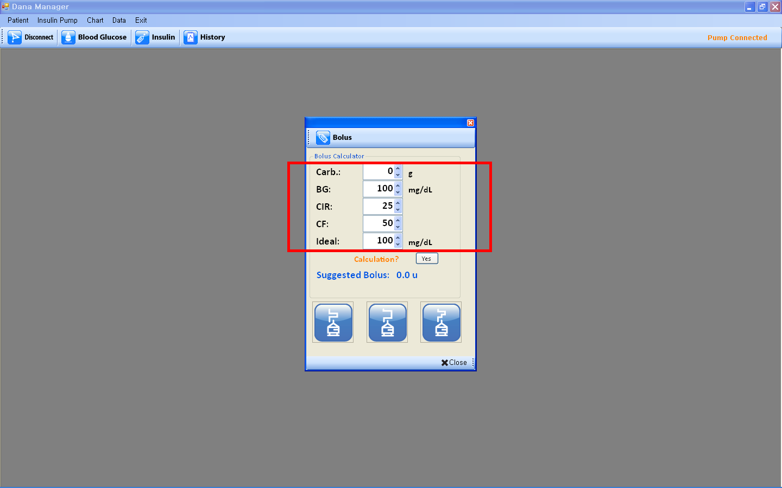
- After adjusting values, please click “Yes”, then you can find the Suggested Bolus units. And choose one bolus type out of step bolus, extended bolus and dual pattern bolus.
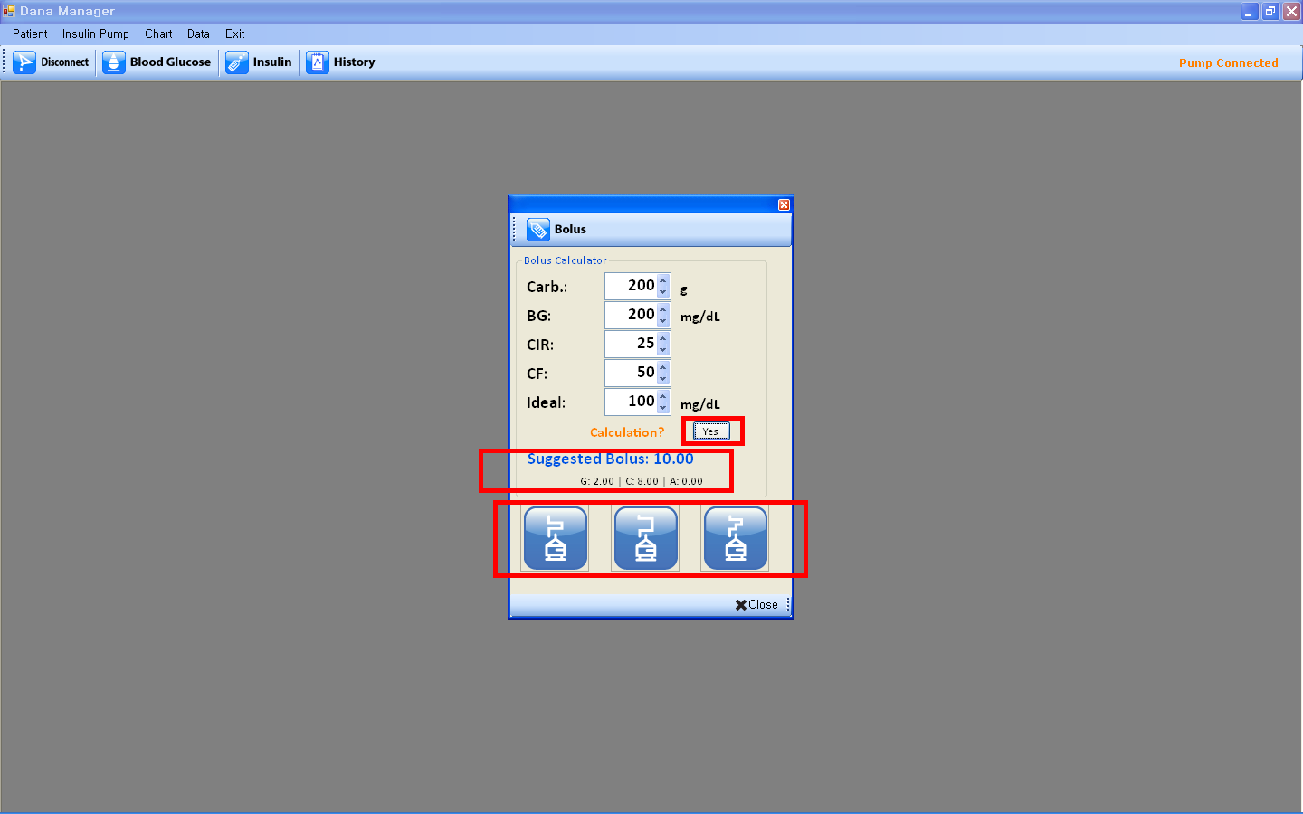
- Once the pop-up screen of the bolus type, please check the insulin amount and then click “Start” on the bottom to start bolus delivery in the pump. If you want to change the insulin amount, please adjust the insulin amount and click “Start”.
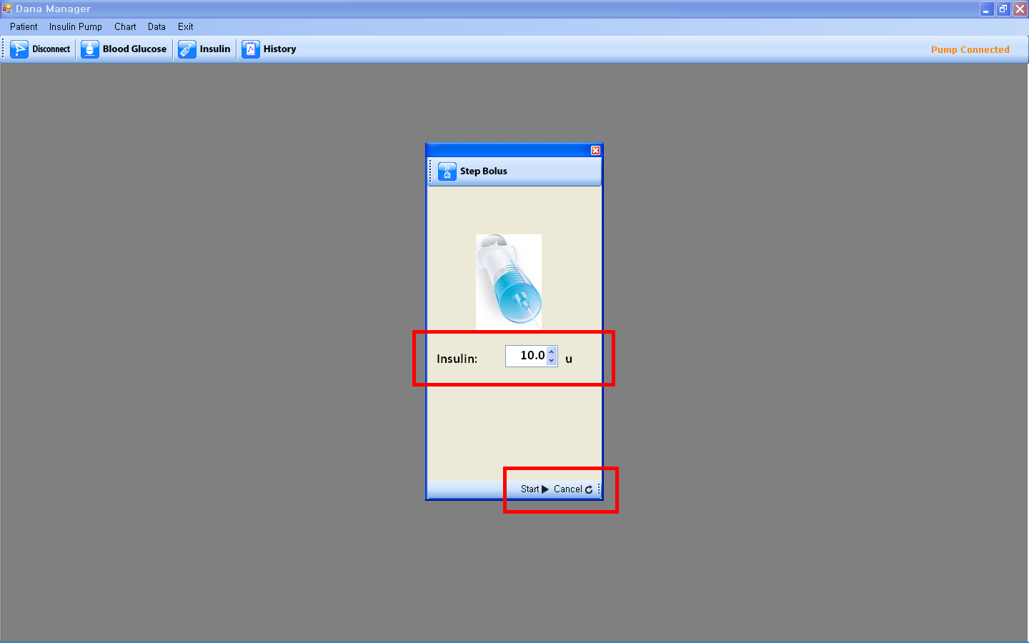

- Temporary Basal
- If you click “Temporary Basal”, Temporary Basal screen will show up.
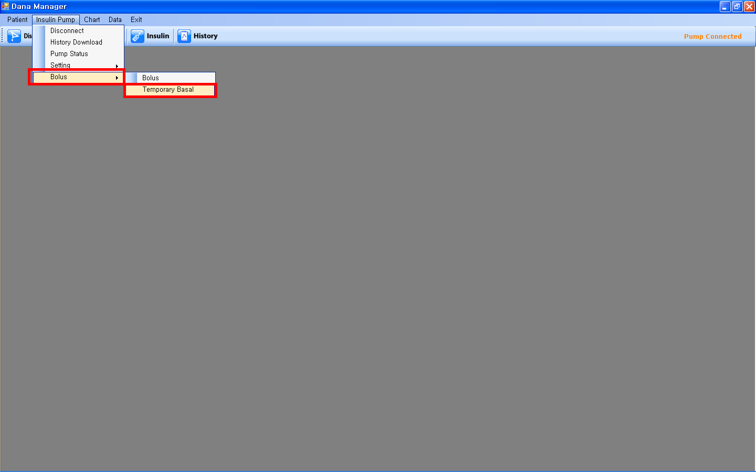

- Please fill in Duration and Ratio, and click “Start” at the bottom to start it.
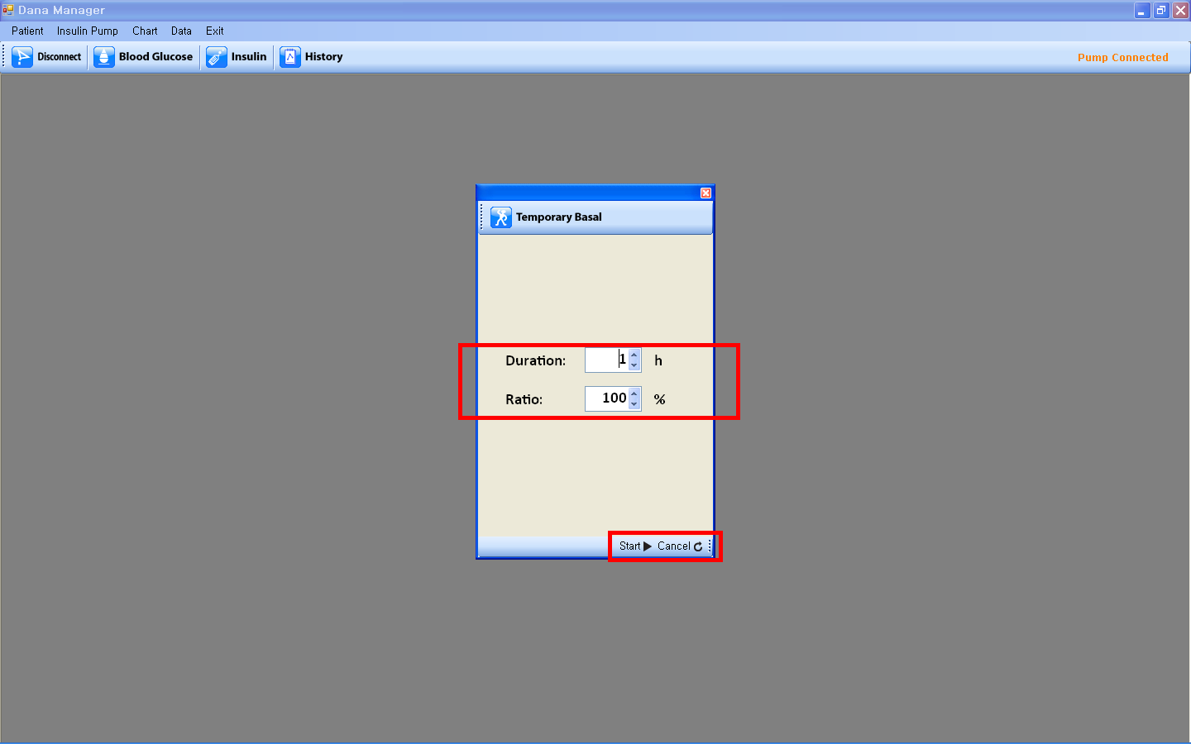
- Chart

- Blood Glucose
- Clicking “Blood Glucose” in the menu performs the same function as a click of the “Blood Glucose” icon. Please see Chapter 3. Function > III. Blood Glucose for detail.

- Insulin
- Click of “Insulin” menu is the same with a click of “Insulin” icon. Please see Chapter 3. Function > IV. Insulin for detail.

- Data

- History
- Click of “History” menu is the same with a click of “History” icon. Please see Chapter 3. Function > V. History for detail.

- Exit You can exit the DANA Monitor.
24 hour Technical Support

07775 642 239

Ordering supplies: Call 01926 833 273

Or

e-mail: info@advancedtherapeuticsuk.com



Advanced Therapeutics (UK) Ltd,
17 Athena Court, Athena Drive
Tachbrook Park, Warwick, CV34 6RT

Tel: +44 (0)1926 833 273 fax: +44 (0)1926 426 028

e-mail: info@advancedtherapeuticsuk.com

